**Inter Region VPC Peering**

**Lab Objective:**

Configure, Test and Make Use of VPC Inter-Region Peering

**Lab Details:**

Create and configure a VPC which shall serve a Test Environment for a simple internet facing application, create and configure another VPC in a different AWS region, this other VPC shall serve as our Production Environment, its configuration shall be identical to that that of the Test Environment but for the naming prefix of its components (‘prod’ instead of ‘dev’). Next we shall peer or connect both VPCs using inter-region peering and finally test to ensure resources in the different VPCs can communicate with each other.

**Introduction:**

A VPC (Virtual Private Cloud) is an isolated network of resources created in the cloud, basically your isolated data center created in the cloud. Inter-region VPC peering permits resources, EC2 instances, databases, lambda functions running in VPCs within different AWS regions to communicate with each other using private addresses without requiring gateways or VPN connections. Traffic using inter-region peering actually stays on the AWS global backbone network and never passes through the public internet where is exposed to threats vectors like DDoS attacks, making it a more secure means of communication. It is a simple and cost effective way to share resources between different regions.

**Case study:**

With the prevalence of remote work, Alpha-Lab, an e-commerce company based in India, has outsourced software development of their customer-facing application to a team in London. Alpha-Labs Development Team in London has created a VPC Test Environment, in their home region - EU (London), configured and provisioned it for the internet-facing Web Application with a secured database at the backend. After demonstrating to the Executives that the application is working as expected, they create an identical VPC which shall serve as the Production Environment, in a different region Asia Pacific (Mumbai) - where the company is headquartered. As a result of regulatory, critical uptime and devops architecture requirements, there is a need for simple, low-cost, secure communication and sharing of resources between the Test and Production environment. In this lab we shall create a VPC Test Environment in the EU (London) AWS region, configure and provision it for the simple internet facing website and in a different region - Asia Pacific (Mumbai), we shall create and configure an identical VPC which shall serve as the Production Environment, perform inter-region VPC peering to connect both Test and Production Environment and finally test to ensure resources in both VPCs can communicate with each other.

**Case Study Diagram:**

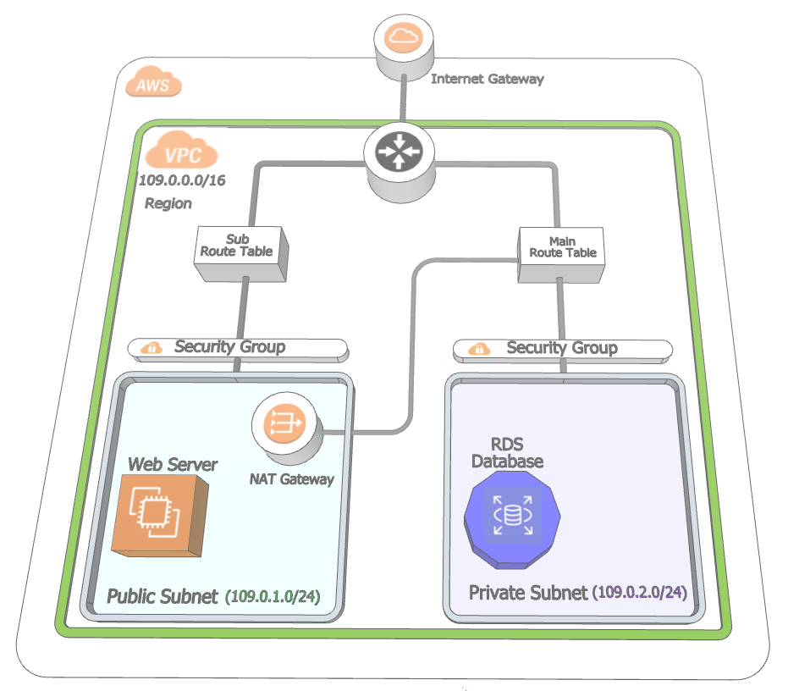

1. Single VPC Architecture



1. Peered Inter-Region VPC

**Tasks:**

1. 1 - Create a Test Environment VPC in EU (London), configure it, provision it for a simple internet facing wed application with a secured database at the back end.
2. 2 - Create an identical VPC environment in a different AWS region - Asia Pacific (Mumbai), this new VPC shall serve as Production VPC Environment.
3. 3 - Carry-out Inter-region VPC Peering to connect Test Environment - EU (London) VPC to Production Environment - Asia Pacific (Mumbai) VPC
4. 4 - Perform connectivity tests to ensure resources in the two different VPCs can communicate with each other.

**Steps:**

1. **Create and Configure a VPC Test Environment (alpha-lab-dev) in EU (London) AWS Region**

***1.1 – Create a VPC***

* + 1. After logging into the AWS console, click on  found on the menu bar, at the top left corner of the console and select 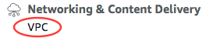

found under Networking & Content Delivery, or type in 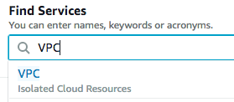 and select it beneath the search bar.

* + 1. At the top right corner of the console, select your AWS region - EU (London)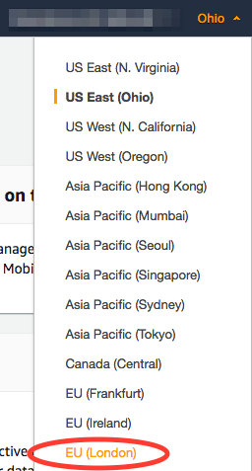
    2. At the top left corner, under the sub-menu ‘Virtual Private Cloud’ - click on 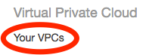 and create a VPC by clicking on , name your VPC - ‘alpha-lap-dev’, add IP address range (IPv4 CIDR Block) - 109.0.0.0/16. For the remaining configurations, leave the default values (No IPv6 CIDr Block, Tenancy = Default).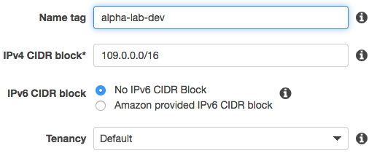 Finally hit  (mid-screen right corner) and click .
    3. Ensure DNS Resolutions and DNS Hostnames are both enabled by highlighting your VPC ‘alpha-lab-dev’

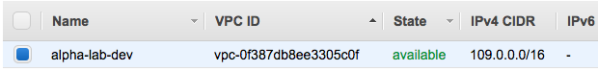

and crosschecking the ‘Description’ tab (lower left corner of the console)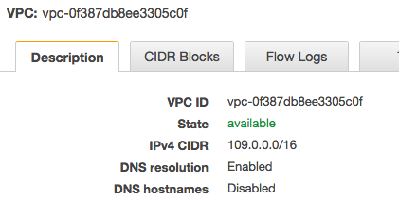.

If they are not enabled, click on  (upper left corner of the console), select 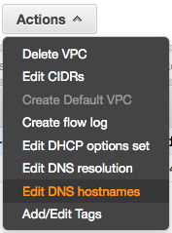 check the box , click  and then .

***1.2 – Create Subnets***

* + 1. Within the ‘Virtual Private Cloud’ Sub-menu

select 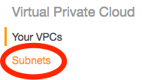, then click  and create three subnets, Name the first subnet ‘alpha-lab-dev-pub’ - ip range 109.0.1.0/24, Using the VPC drop-down menu, assign it to ‘alpha-lab-dev’ VPC. For the Availability Zone, select ‘eu-west-2a’.

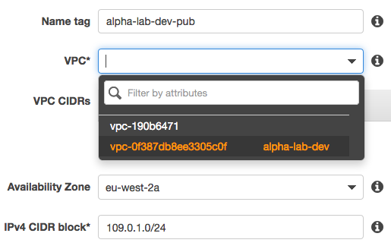

Click  (middle left corner of the console) and then .

* + 1. Name the second subnet ‘alpha-lab-dev-priv’ with IP address range 109.0.2.0/24. Using the VPC drop-down menu, assign it to ‘alpha-lab-dev’ VPC. For the Availability Zone, select ‘eu-west-2b’.

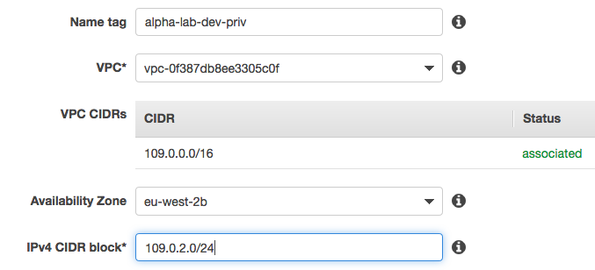

Click  (middle left corner of the console) and then .

1. Name the third subnet ‘alpha-lab-dev-priv-2’ with IP address range 109.0.3.0/24. Using the VPC drop-down menu, assign it to ‘alpha-lab-dev’ VPC. For the Availability Zone, select ‘eu-west-2c’.

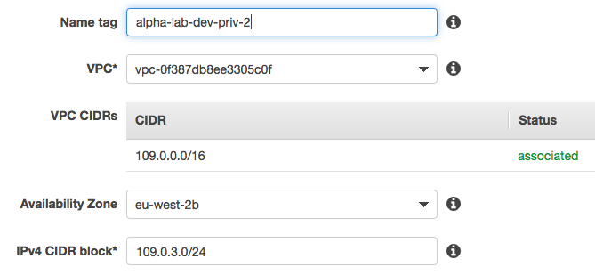

Click  (middle left corner of the console) and then .

***1.3 – Create Security Groups***

* + 1. Beneath the ‘Virtual Private Cloud’ menu, click 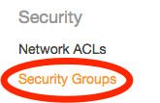

found within the ‘Security’ sub-menu. Create two Security Groups,

Click  (upper left corner of the console)

Name the first one - ‘alpha-lab-dev-sg-pub’, Description - ‘Allow Internet HTTP and HTTPS traffic’, VPC - select ‘alpha-lab-dev’ from the drop-down menu. Click  (middle left corner of the console) and then click .

Name the second one ‘alpha-lab-dev-sg-priv’,

Description - ‘Allow SSH access to Developers’, VPC - select ‘alpha-lab-dev’ from the drop-down menu.

Click  (middle left corner of the console) and then click .

* + 1. Configure the two Security Groups created in the previous step - still within ‘Security Groups’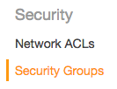, look for ‘Group Name’ on the Security Group table and highlight ‘alpha-lab-dev-sg-pub’.

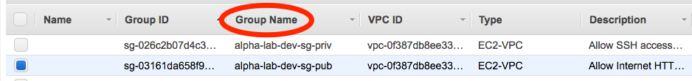

On the lower left corner of the console, click the second tab ‘Inbound Rules’

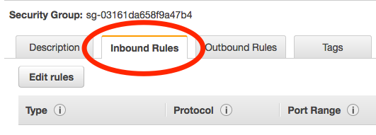

Click , after that click , in the field - Type - select ‘HTTP’ from the drop-down menu, this should populate Protocol - TCP and Port Range - ’80’, Source - select ‘Anywhere’ from the drop-down menu, Description - type in ‘Allow Internet - http Traffic’

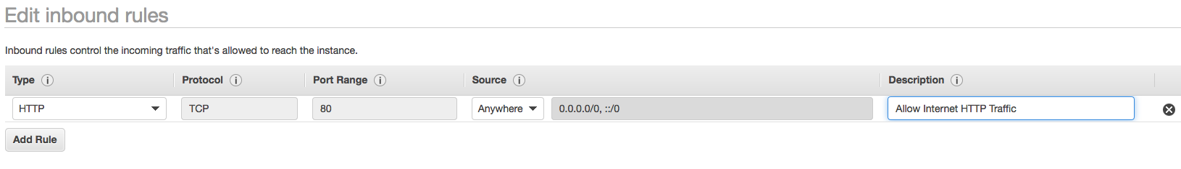

* + 1. Add a **second rule** to let in https - Click , in the field ‘Type - select ‘HTTPS’ from the drop-down menu, this should populate Protocol - ’TCP’ and Port Range - ‘443’, Source - select ‘Anywhere’ from the drop-down menu, Description - type in ‘Allow internet HTTPS Traffic’.

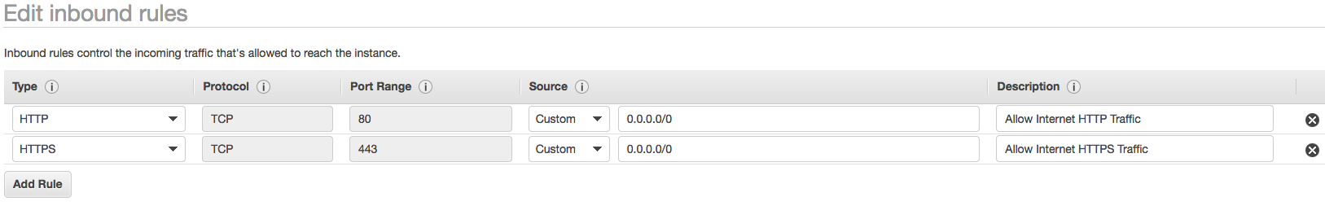

1. Add a **third rule** to let in SSH login access, Click , in the field in the field ‘Type - select ‘SSH’ from the drop-down menu, this should populate Protocol - ’TCP’ and Port Range - ‘22’, Source - select ‘My IP’ from the drop-down menu, Description - type in ‘Allow SSH login access for Developers’.

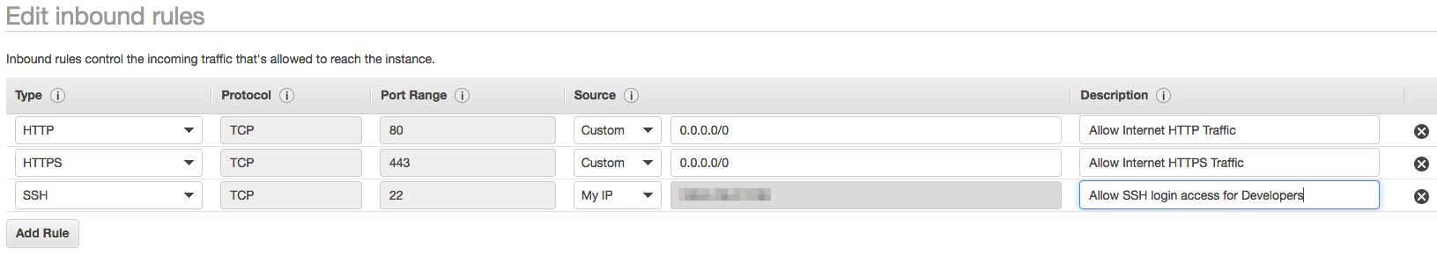

1. Add a **fourth rule** to let in connectivity tests (ping requests) into this security group,

Click , in the field ‘Type - select ‘Custom ICMP Rule IPv4’ from the drop-down menu, Protocol - select ’Echo Requests’ from the drop-down menu and Port Range - ‘N/A’, Source - select ‘Anywhere’ from the drop-down menu, Description - type in ‘Allow Server Connectivity Tests - Requests’.

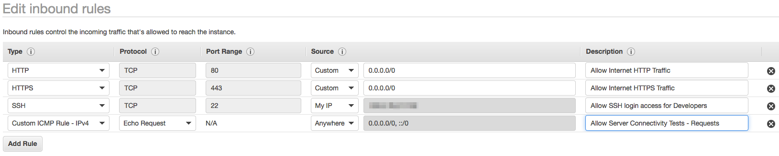

1. Add a **fifth rule** to let out connectivity tests (ping replies) from this security,

Click , in the field ‘Type - select ‘Custom ICMP Rule PIv4’ from the drop-down menu, Protocol - select - ’Echo Reply’ from the drop-down menu and Port Range - ‘N/A’, Source - select ‘Anywhere’ from the drop-down menu, Description - type in ‘Allow Server Connectivity Tests - Replies’.

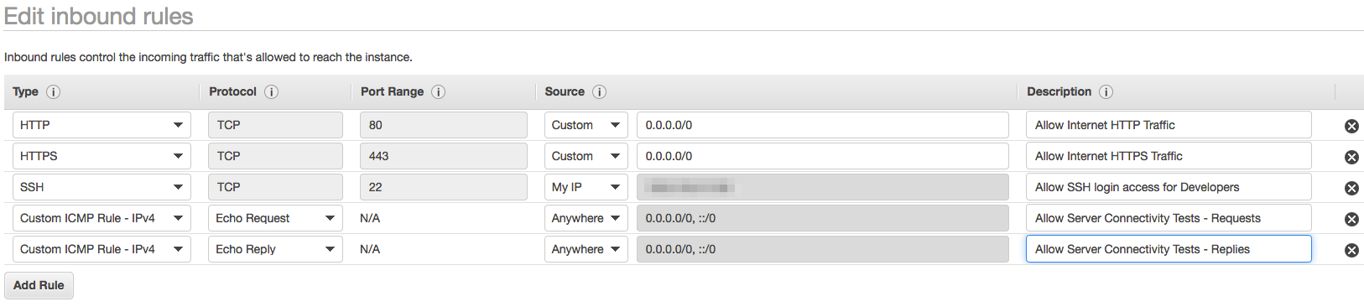

Click (middle left corner of the console) and then click .

1. Hover your cursor next to the Group ID of ‘alpha-lab-dev-sg-pub’ found on the lower left corner of the console, on the ‘Description tab and click on the copy icon to copy ‘alpha-lab-dev-sg-pub’s Group ID.

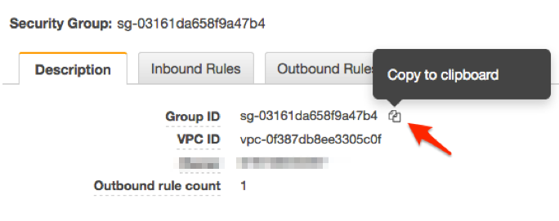

Now highlight the Security Group ’alpha-lab-dev-sg-priv’ in the Security Group table

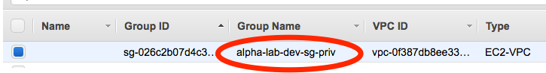

On the lower left corner of the console, click the second tab ‘Inbound Rules’

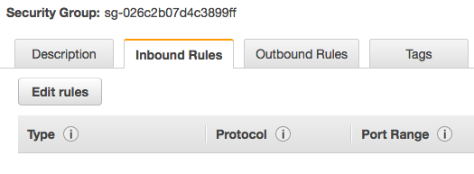

1. Add a **first rule** to let in web traffic into the private(database) security group. Click , after that click , In the field ‘Type’ - select ‘MySQL/Aurora’ from the drop-down menu, this should populate Protocol - ’TCP’ and Port Range - ‘3306’, Source - select ‘Custom’ from the drop-down menu and paste in, the Security Group ID of ‘alpha-lab-dev-sg-pub’ which you copied above, Description - type in ‘Allow Database traffic from the Web Server Security Group’.

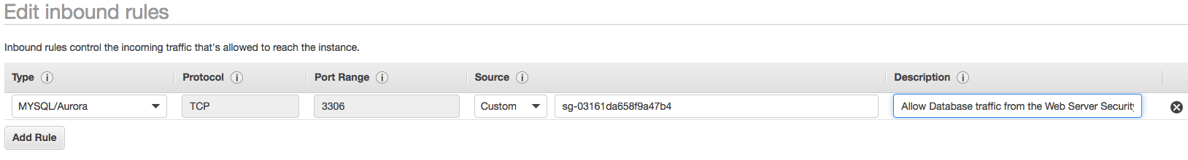

1. Add a **second rule** to let in SSH login access, Click , in the field ‘Type - select ‘SSH’ from the drop-down menu, this should populate Protocol - ’TCP’ and Port Range - ‘22’, Source - select ‘My IP’ from the drop-down menu, Description - type in ‘Allow SSH login access for Developers’.

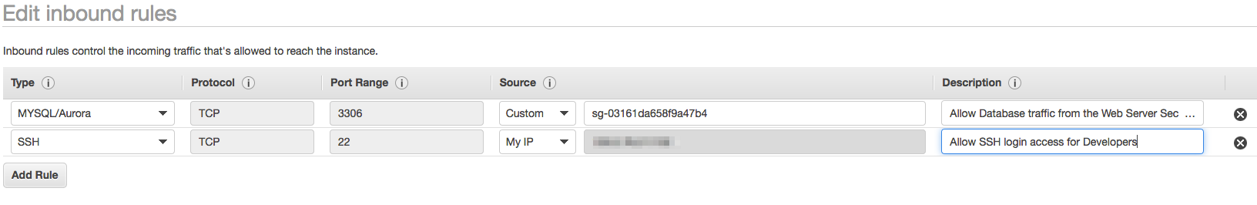

Click (middle left corner of the console) and then click .

***1.4 – Create an Internet Gateway***

1. Create an **Internet Gateway** - within the ‘Virtual Private Cloud’ menu

click on ‘Internet Gateways

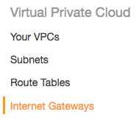

create an Internet Gateway by clicking  on the upper left corner of the console, name it ‘alpha-lab-dev-int-gw’, click  and then  . Attach your newly created Internet Gateway to your VPC, ensure it is highlighted

1. Click on  and select ‘Attach to VPC’ 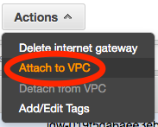, click VPC and select ‘alpa-lab-dev’ from the drop down menu

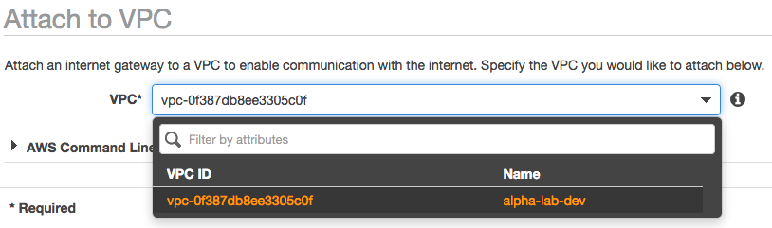

Hit the  button.

***1.5 – Create a Sub or Custom Route Table***

1. Create a **Sub or Custom Route Table** for your VPC - within the ‘Virtual Private Cloud’ menu, click on ‘Route Tables’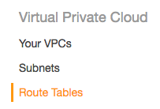,

create a Route Table by clicking on  the upper left corner of the console, name it ‘alpha-lab-dev-sub-rt’, click VPC and select ‘alpha-lab-dev’ from the drop-down menu to associate it with your VPC

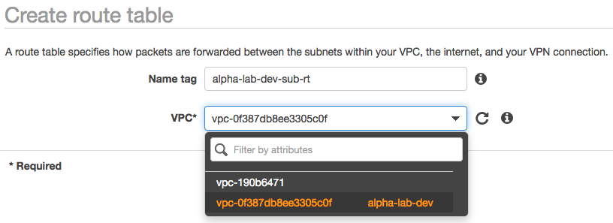.

Click  and then the button.

1. Highlight your newly created sub Route Table by clicking anywhere on its row in the Route Table table.

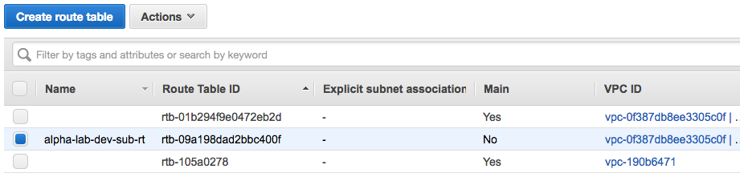

Click on the ‘Routes’ tab - second tab (lower left corner of your console),

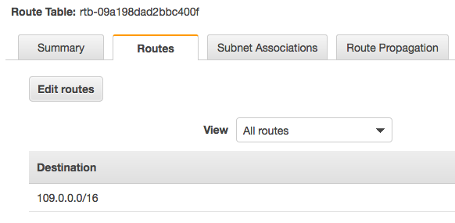

click on , then on . Beneath the field ’Targets, click and select ‘Internet Gateway’ and select the Internet Gateway ‘alpha-lab-dev-int-gw’ from the drop-down menu, Destination - key in ‘0.0.0.0/0’.

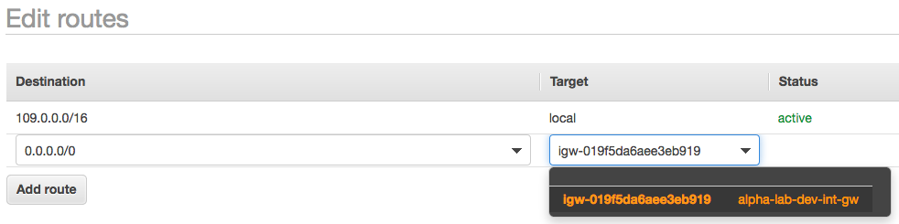

Hit the  button and then the  button.

1. Explicitly assign your public subnet ‘alpha-lab-dev-pub’ to your sub Route Table ‘alpha-lab-dev-sub-rt’. Ensure your sub Route Table is highlighted by clicking anywhere on its row in the Route Table table,



then click on the third tab - ‘Subnet Associations’ (lower left corner of the console)

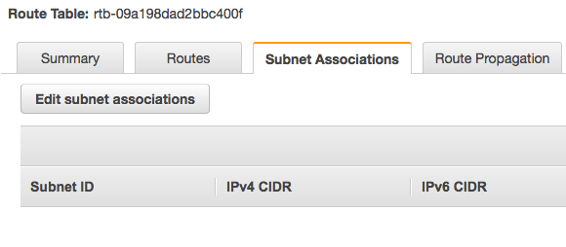

and click the ‘Edit subnet Associations’ button, highlight your public subnet ‘alpha-lab-dev-pub’

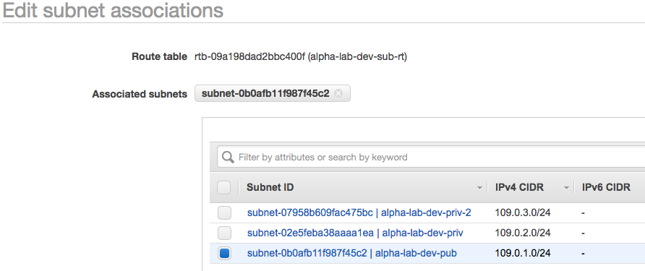

and hit the  button.

***1.6 – Create a NAT Gateway***

1. Create a **NAT Gateway** and route internet traffic from the Main Route Table to it. Within the ‘Virtual Private Cloud’ menu, click on ‘NAT Gateways,

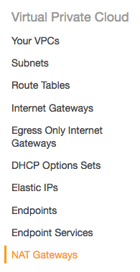

create a NAT Gateway by clicking  on the upper left corner of the console. Next to the field subnets - click and select your public subnet ‘alpha-lab-dev-pub’, next to the ‘Elastic IP Allocation ID – click 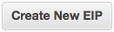.

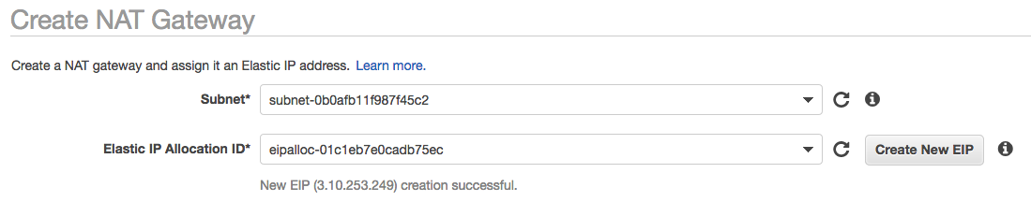

Click the button.

1. Beneath the green success prompt, click , highlight your Main Route Table by clicking on the row and checking the ‘Summary’ tab for ‘alpha-lab-dev and ‘Main’ field - Yes.

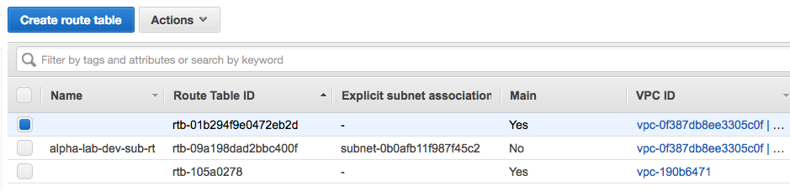

Click the ‘Route’ tab,

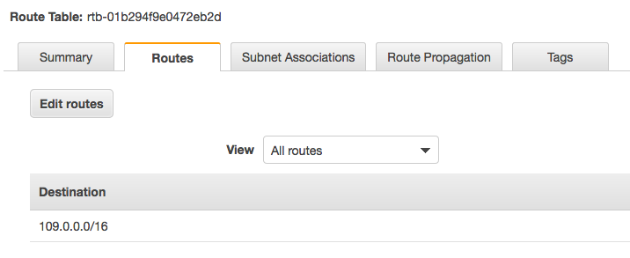

followed by the  button, then click the  button, Beneath the field ’Targets, click and select ‘NAT Gateway’ and select the populated NAT Gateway from the drop-down menu, Destination - key in ‘0.0.0.0/0’.

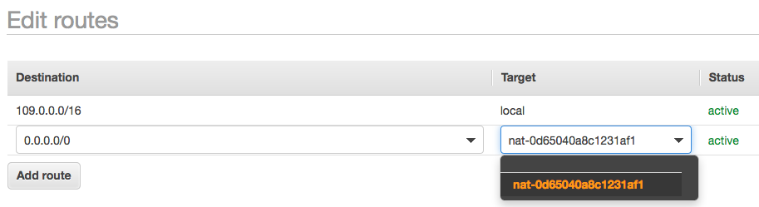

Hit the  button and then the  button.

***1.7 – Provision a Linux EC2 Instance***

1. **Provision a Linux EC2 instance** in the public subnet which shall serve as our Web Server. Click on  (upper left corner of the console) that is on the AWS menu bar, click on ‘EC2’ found within the sub-menu ‘Compute’

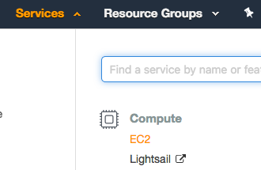

or Key in ‘EC2’ in the search bar and select it from the drop-down menu.

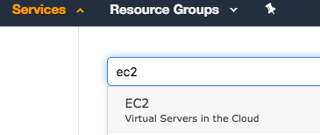

1. Click  (midway left side of the console), in the tab ‘Quick Start’ choose ‘Amazon Linux AMI

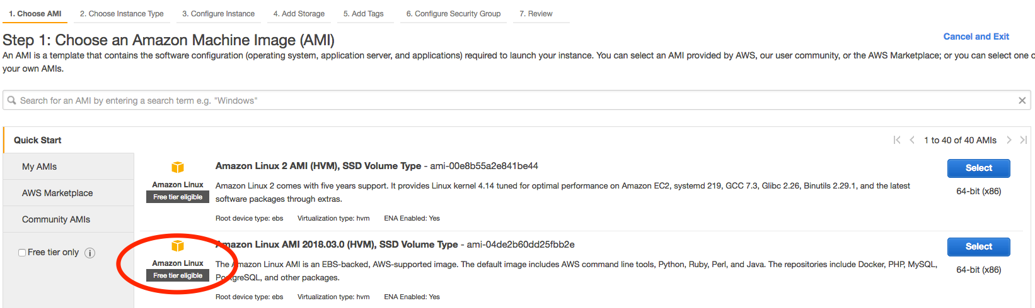

select a ‘t2.micro’ Instance Type, by clicking anywhere on its row.

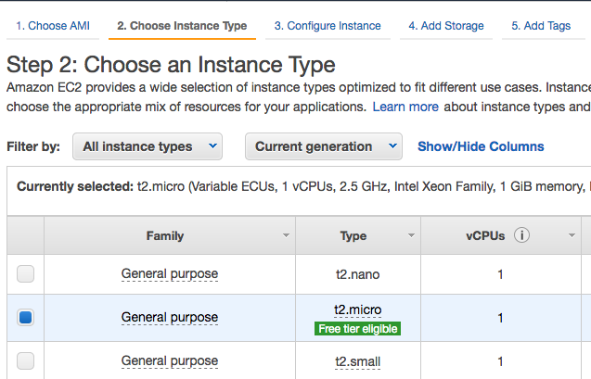

1. Click the button (bottom right corner of the console). Click the drop-down menu next to the Network field and select your VPC ‘alpha-lab-dev’, Subnet - select ‘alpha-lab-dev-pub’, Auto-Assign Public IP - select ‘Enabled’, Leave the remaining configurations in their default state.

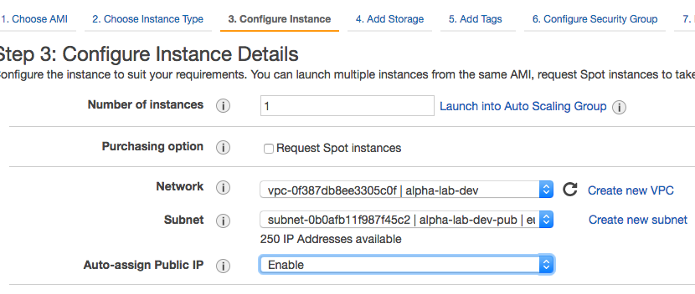

1. Now click on the 6th tab - 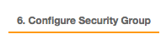 (upper section of the console, below the AWS menu bar), click the ‘Select an existing Security Group’ radio button, highlight ‘alpha-lab-dev-sg-pub’.

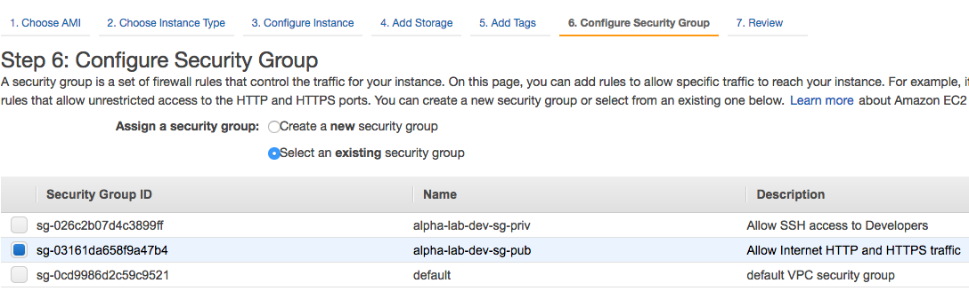

1. Click the  button ( bottom right corner of the console), after that click the  button, then in the Key Pair dialogue box, click the drop down and select ‘Create new Key Pair, name your Kay Pair ‘alpha-lab-dev-pup-kp’

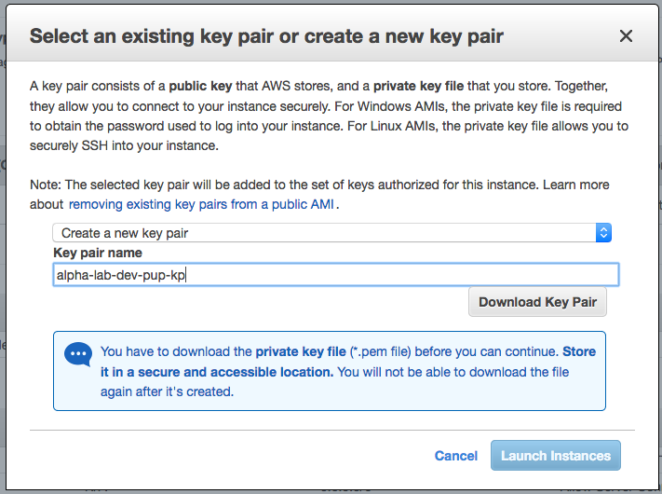

download your Key Pair by clicking the  button.

Finally click  to launch your EC2 instance.

1. Login into your newly created EC2 Instance via SSH. After launching your Instance, click on the  button (lower right corner of the console). Next to the ‘Launch Instance’ button click the 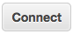 button, Leave the default radio button selection ‘I would like to connect with - A standalone SSH Client’

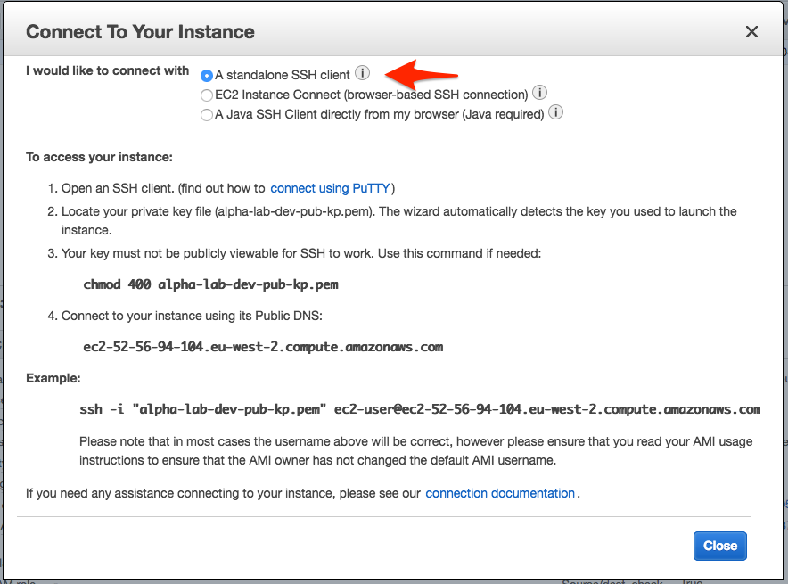

If you working on a Mac or Linux computer, launch your terminal, if you are on a Windows computer install and use a Putty ssh client. After launching your terminal, cd or change directory to the location where you saved your Key Pair (in the terminal, type in ‘cd Downloads’ and hit Enter.

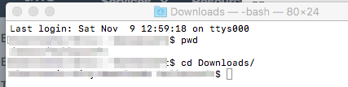

1. Copy the command ‘chmod 400 alpha-lab-dev-pub-kp.pem’ from the dialogue box in the console, paste it in your terminal and hit Enter (this will change the permission of your key pair making it viewable by ssh.

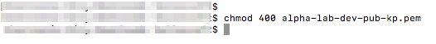

1. Copy the command ‘ssh -i "alpha-lab-dev-pub-kp.pem" ec2-user@ec2-3-8-102-102.eu-west-2.compute.amazonaws.com’ (your instance name) from the dialogue box In the console, paste in your terminal and hit enter to log into your EC2 instance via ssh,

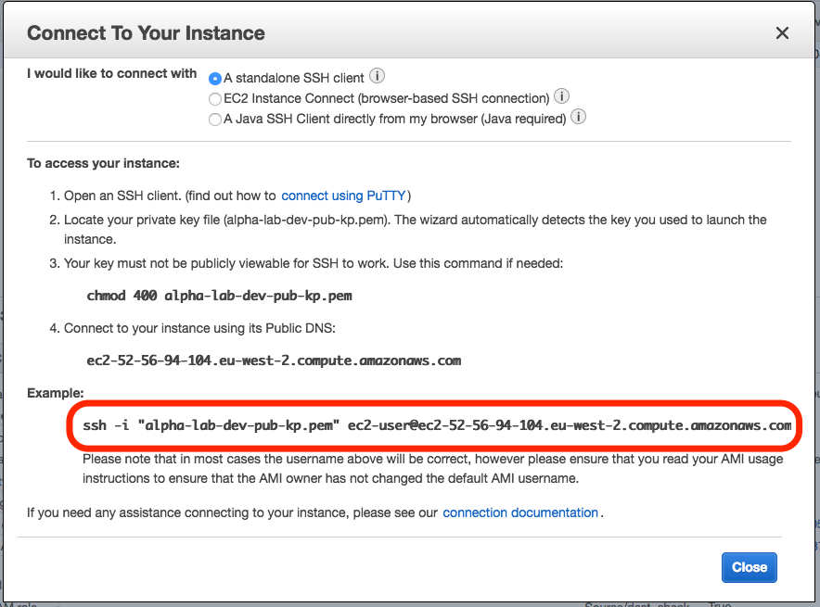

you will receive a warning about the hosts authenticity and wether you are sure you want to login, type in ‘yes’ and hit Enter.

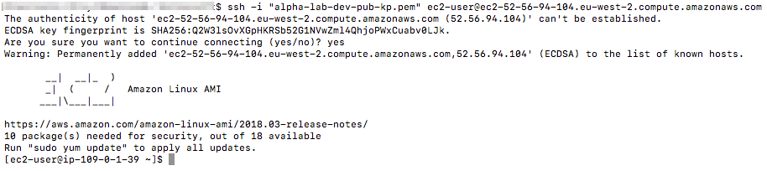

1. Once you have logged in, key in ‘sudo su - ‘ and hit Enter to upgrade your privileges on the systems and ‘yum -y update’ to update your EC2 instance.

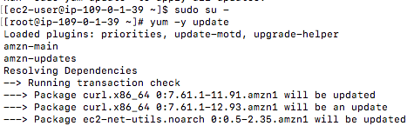

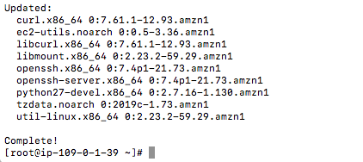

1. Next install the Apache Web Server by keying in ‘yum install -y httpd24 httpd24-tools mod24_ssl’ and hitting Enter.

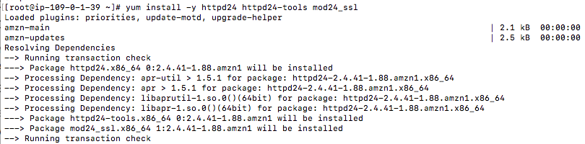

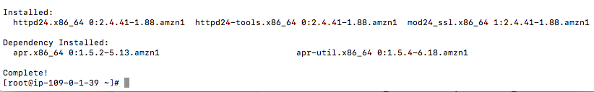

1. After installation set Apache Server to start automatically upon system start up key in ‘chkconfig httpd on’ and hit enter, then key again ‘service https start’ and hit Enter.

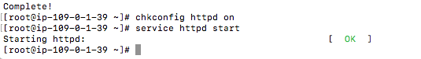

1. Name your Web Server and Test to confirm that it is up and running.

Highlight your instance and click the icon below the name field and name your instance ‘alpha-lab-dev-web’

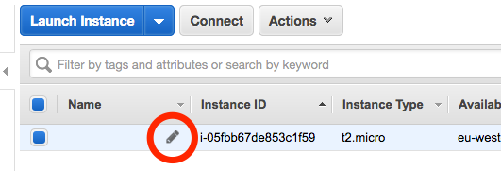 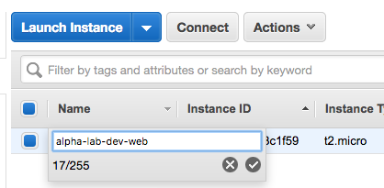

1. In the ‘Descriptions’ tab, hover your curser next to the ‘IPv4 Public IP (lower right corner of the console) and click on the copy icon to copy the public IP address of your EC2 instance.

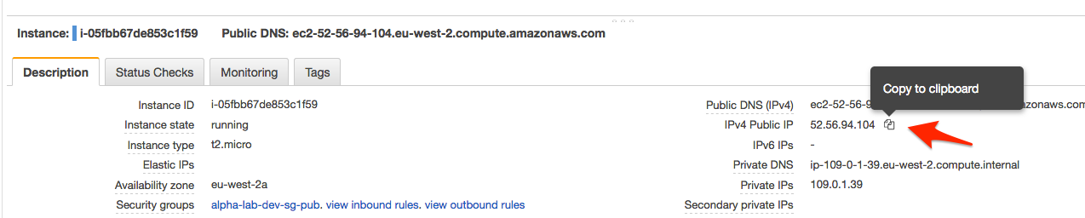

1. Paste the copied IP address in a new tab in your web browser and hit Enter.

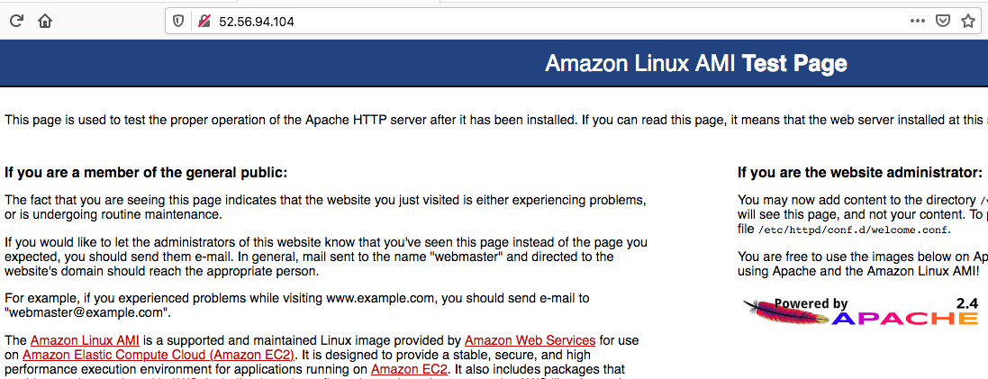

If you see the page above: ‘Amazon Linux Ami Test Page… this page is use to test the proper operation if the Apache HTTP server after it has been installed…’ Then your congratulations your configurations are CORRECT and your Web Server in the public subnet is accessible to every user on the internet.

***1.8 – Provision an RDS - MySQL Database***

1. Provision an RDS - MySQL database and place it in the private subnet where it only receives ingress database traffic from your public / Web Servers Security Group. Click on  (upper left corner of the console that is on the AWS menu bar, click on ‘RDS’ found within the sub-menu ‘Database’ or Key in ‘RDS’ in the search bar and select it from the drop-down menu.

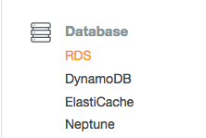 OR 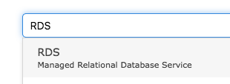

1. Click the  button on the lower left section of the console, Leave the default ‘Standard Create’ Database Creation Method, Engine Options - click MySQL, Edition - leave the default selection, templates - select / click on ‘Free Tier,

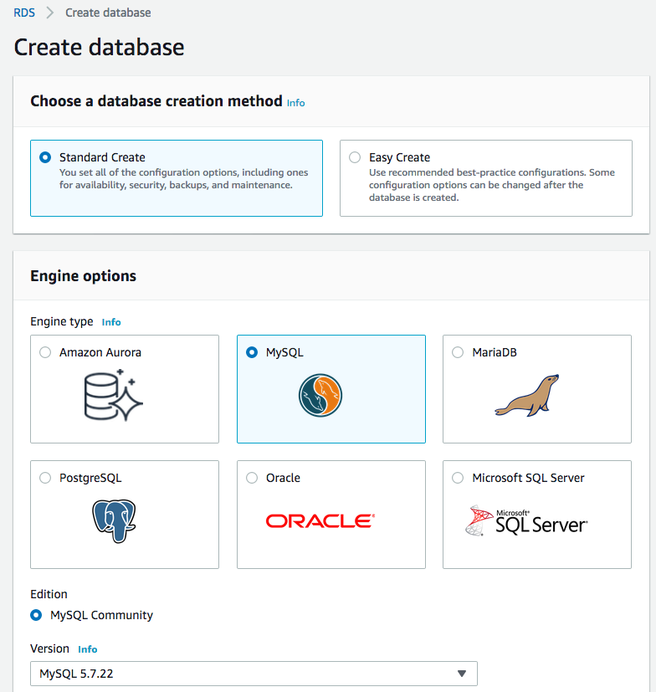

1. Within Settings, DB Instance Identifier - ‘alpha-lab-dev-db’, Master Username - ‘alpha_db_root’, Master password ‘manager101’, Confirm password ‘manager101’.

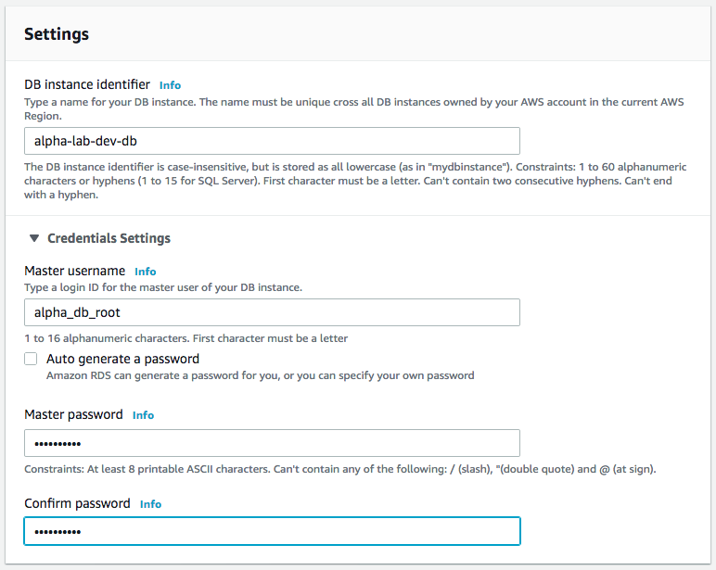

1. For DB Instance Size, Storage: uncheck ‘Storage autoscaling’, Availability & Durability - leave the default values for the remaining configurations.

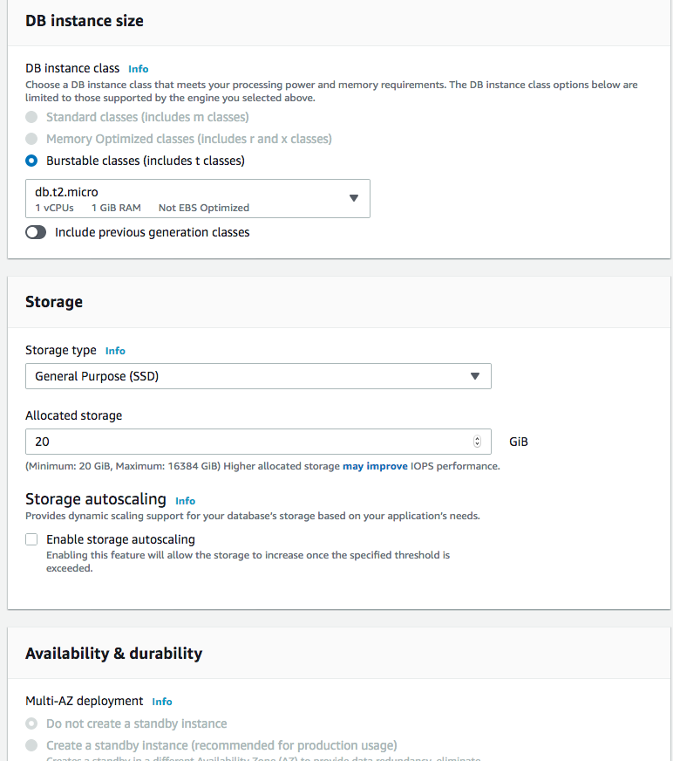

1. Within Connectivity, click VPC and select ‘alpha-lad-dev’, Within ‘Additional Connectivity Configurations’ Subnet Group - leave default (Create New DB Subnet Group), Public Accessibility - select ‘No’, VPC Security Group - select ‘Choose Existing and select ‘alpha-lab-dev-sg-priv’ from the drop-down menu.

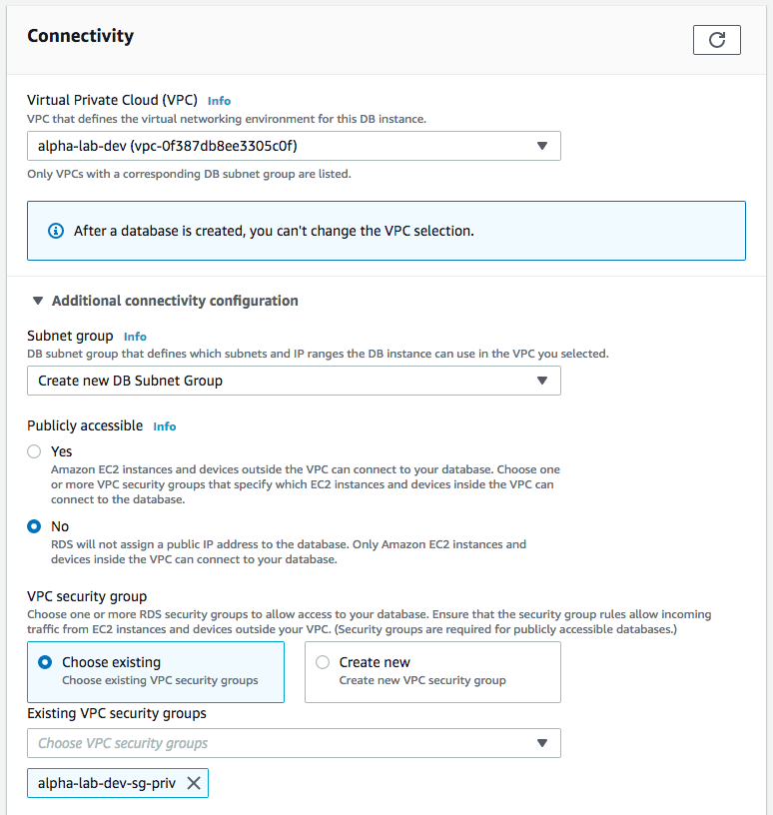

1. Database Port - leave default (3306), Database Authentication - leave default (Password Authentication), Within Additional Configurations, Initial Database Name - ‘alpha_lab_dev_db001’. Under ‘Backup – Uncheck ‘Enable automatic backups and Leave all other configurations with default values.

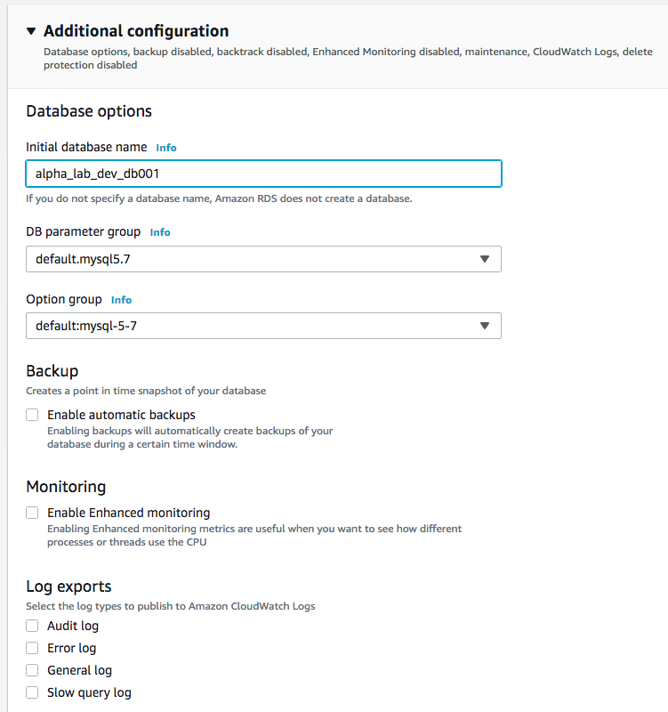

scroll to the end, click the  button.

1. **Test your RDS database connectivity using MySQL Workbench** - an SQL Client Tool, which performs an SSH login into your Web Server in the public subnet and from your web server, it established a connection to your RDS database on port 3306. In your MySQL Connection / login window, you will key in the following credentials. Connection Method - select Standard TCP/IP over SSH, SSH Hostname - ‘Your Web Servers public DNS or public IP address’, SSH Username - ‘ec2-user’, SSH Key File - ‘/path/alpha-lab-dev-pup-kp.pem’, MySQL Hostname - ‘copy and paste in your RDS-endpoint’ ( RDS > Databases > alpha-lab-dev-db > connectivity & security > endpoint ), MySQL Port - ‘3306’, Username - ‘alpha_db_root’, Password - ‘mamaner101’. Finally click the Test Connection or Connect button.

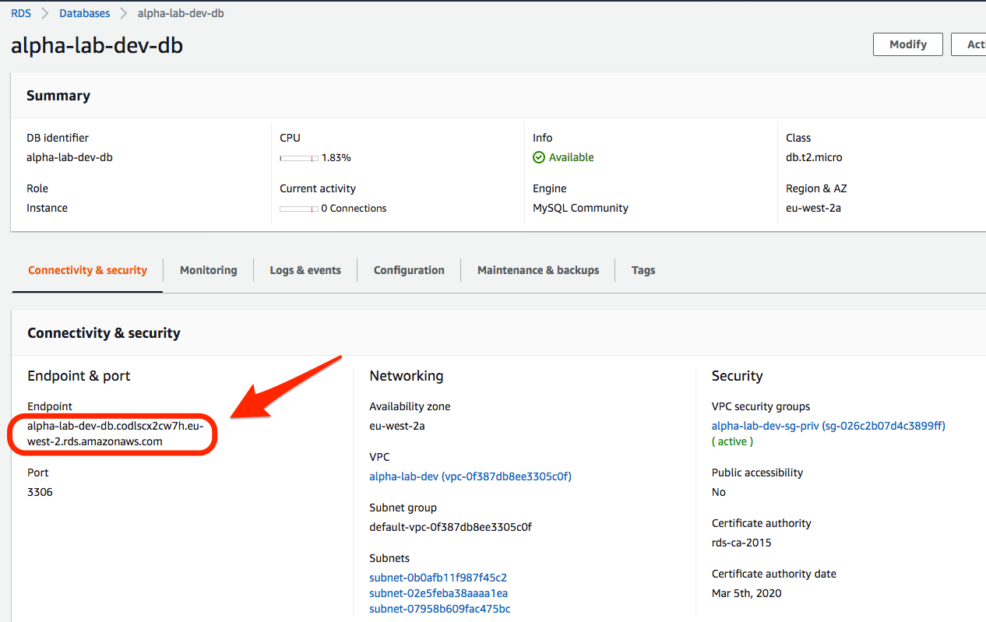

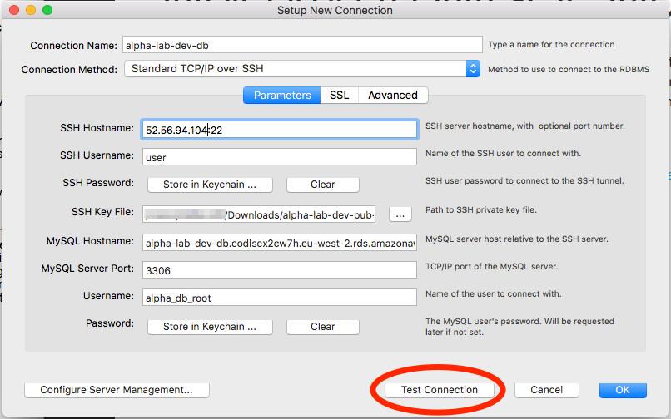

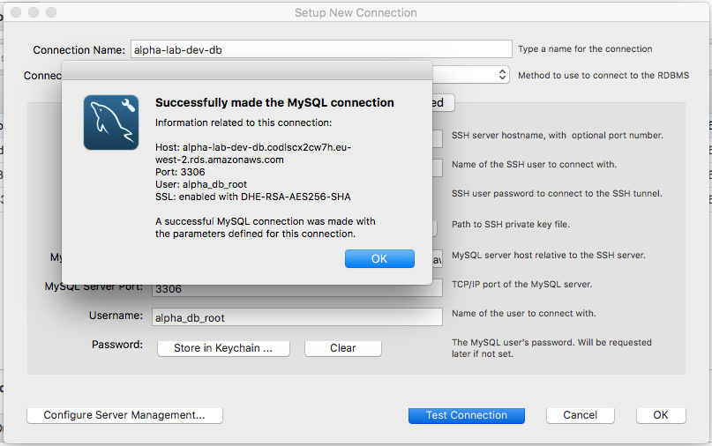

1. **Create and Configure a VPC Production Environment (alpha-lab-prod) in Asia Pacific (Mumbai) AWS Region**

***2.1 – Create a VPC***

* + 1. After logging into the AWS console, click on  found on the menu bar, at the top left corner of the console and select 

found under Networking & Content Delivery, or type in  and select it beneath the search bar.

* + 1. At the top right corner of the console, select your AWS region – Asia Pacific (Mumbai)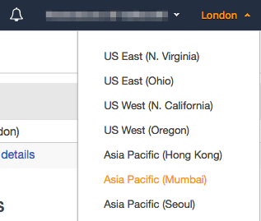
    2. **Create a VPC** - At the top left corner, under the sub-menu ‘Virtual Private Cloud’ - click on  and create a VPC by clicking on , name your VPC - ‘alpha-lap-prod’, add IP address range (IPv4 CIDR Block) - 105.0.0.0/16. For the remaining configurations, leave the default values (No IPv6 CIDr Block, Tenancy = Default).

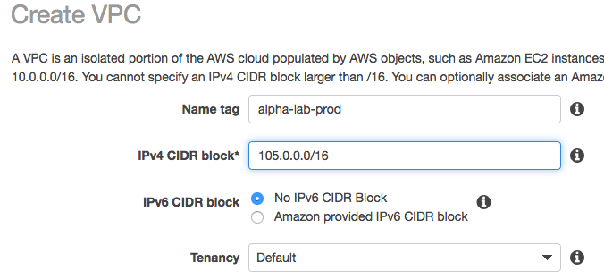

Finally hit  (mid-screen right corner) and click .

* + 1. **Ensure DNS Resolutions and DNS Hostnames are both enabled**. Highlight your VPC ‘alpha-lab-prod’ 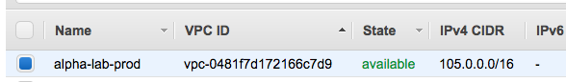

and crosschecking the ‘Description’ tab (lower left corner of the console)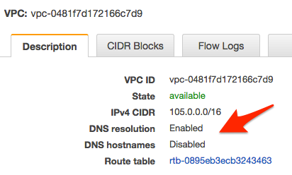.

If they are not enabled, click on  (upper left corner of the console), select  check the box , click  and then .

***2.2 – Create Subnets***

* + 1. **Create Subnets** - Within the ‘Virtual Private Cloud’ Sub-menu

select 

then click  and create three subnets, Name **the first subnet** ‘alpha-lab-prod-pub’ - ip range 105.0.1.0/24, Using the VPC drop-down menu, assign it to ‘alpha-lab-prod’ VPC. For the Availability Zone, select ‘ap-south-1a’.

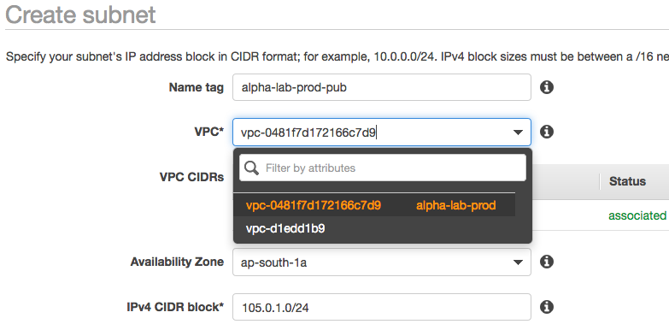

Click  (middle left corner of the console) and then .

* + 1. Name **the second subnet** ‘alpha-lab-prod-priv’ with IP address range 105.0.2.0/24. Using the VPC drop-down menu, assign it to ‘alpha-lab-prod’ VPC. For the Availability Zone, select ‘ap-south-1b’.

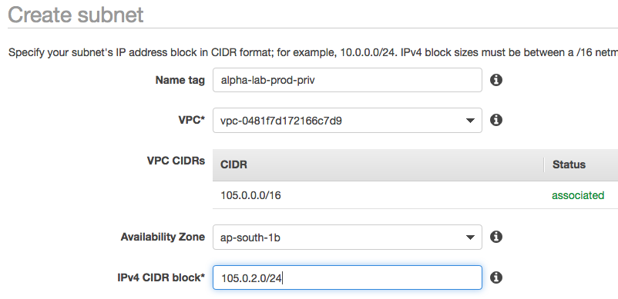

Click  (middle left corner of the console) and then .

* + 1. Name **the third subnet** ‘alpha-lab-prod-priv-2’ with IP address range 105.0.3.0/24. Using the VPC drop-down menu, assign it to ‘alpha-lab-prod’ VPC. For the Availability Zone, select ‘ap-south-1c’.

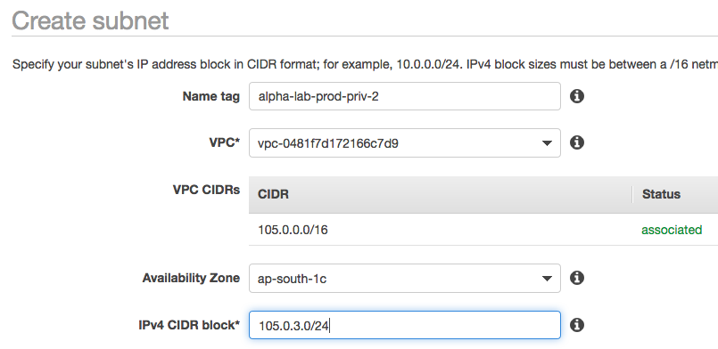

Click  (middle left corner of the console) and then .

***2.3 – Create Security Groups***

* + 1. Create Security Groups

Beneath the ‘Virtual Private Cloud’ menu, click 

found within the ‘Security’ sub-menu. Create two Security Groups,

Click  (upper left corner of the console)

Name **the first one** - ‘alpha-lab-prod-sg-pub’, Description - ‘Allow Internet HTTP and HTTPS traffic’, VPC - select ‘alpha-lab-prod’ from the drop-down menu.

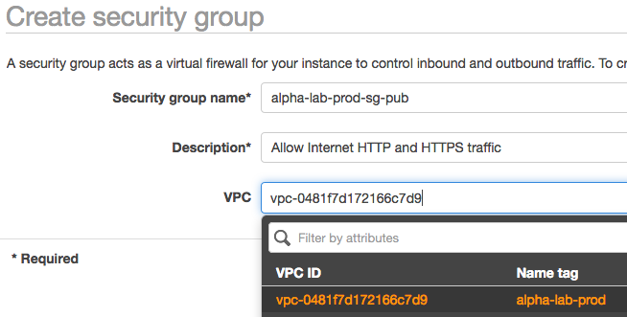

Click  (middle left corner of the console) and then click .

* + 1. Name **the second one** ‘alpha-lab-prod-sg-priv’,

Description - ‘Allow Database traffic from Web Server Security Group’, VPC - select ‘alpha-lab-prod’ from the drop-down menu.

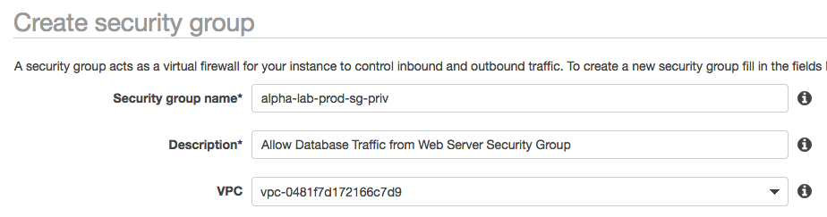

Click  (middle left corner of the console) and then click .

* + 1. **Configure the two Security Groups created in the previous step** - still within ‘Security Groups’, look for ‘Group Name’ on the Security Group table and highlight ‘alpha-lab-prod-sg-pub’.

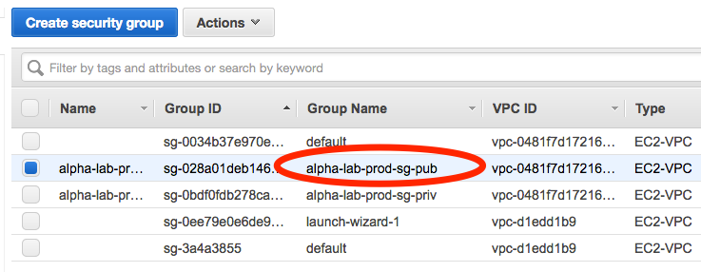

On the lower left corner of the console, click the second tab ‘Inbound Rules’

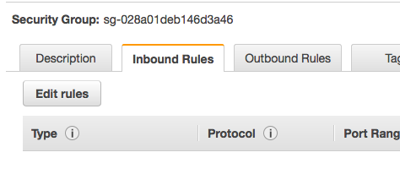

Click , after that click , in the field - Type - select ‘HTTP’ from the drop-down menu, this should populate Protocol - TCP and Port Range - ’80’, Source - select ‘Anywhere’ from the drop-down menu, Description - type in ‘Allow Internet - http Traffic’



* + 1. Add a **second rule** to let in https - Click , in the field ‘Type - select ‘HTTPS’ from the drop-down menu, this should populate Protocol - ’TCP’ and Port Range - ‘443’, Source - select ‘Anywhere’ from the drop-down menu, Description - type in ‘Allow internet HTTPS Traffic’.



Click (middle left corner of the console) and then click .

* + 1. Add a **third rule** to let in SSH login access, Click , in the field in the field ‘Type - select ‘SSH’ from the drop-down menu, this should populate Protocol - ’TCP’ and Port Range - ‘22’, Source - select ‘My IP’ from the drop-down menu, Description - type in ‘Allow SSH login access for Developers’.



* + 1. Add a **fourth rule** to let in connectivity tests (ping requests) into this security group,

Click , in the field ‘Type - select ‘Custom ICMP Rule IPv4’ from the drop-down menu, Protocol - select ’Echo Requests’ from the drop-down menu and Port Range - ‘N/A’, Source - select ‘Anywhere’ from the drop-down menu, Description - type in ‘Allow Server Connectivity Tests - Requests’.



* + 1. Add a **fifth rule** to let out connectivity tests (ping replies) from this security,

Click , in the field ‘Type - select ‘Custom ICMP Rule PIv4’ from the drop-down menu, Protocol - select - ’Echo Reply’ from the drop-down menu and Port Range - ‘N/A’, Source - select ‘Anywhere’ from the drop-down menu, Description - type in ‘Allow Server Connectivity Tests - Replies’.



Click (middle left corner of the console) and then click .

* + 1. Hover your cursor next to the Group ID of ‘alpha-lab-prod-sg-pub’ found on the lower left corner of the console, on the ‘Description tab and click on the copy icon to copy ‘alpha-lab-prod-sg-pub’s Group ID.

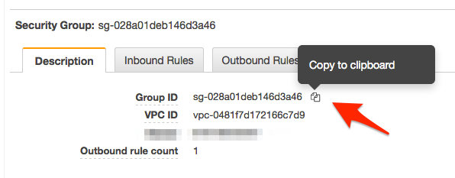

Now highlight the Security Group ’alpha-lab-prod-sg-priv’ in the Security Group table

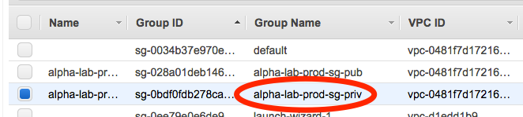

On the lower left corner of the console, click the second tab ‘Inbound Rules’

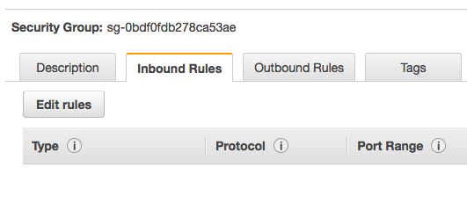

* + 1. Add a **first rule** to let in web traffic into the private(database) security group. Click , after that click , In the field ‘Type’ - select ‘MySQL/Aurora’ from the drop-down menu, this should populate Protocol - ’TCP’ and Port Range - ‘3306’, Source - select ‘Custom’ from the drop-down menu and paste in, the Security Group ID of ‘alpha-lab-prod-sg-pub’ which you copied above, Description - type in ‘Allow Database traffic from the Web Server Security Group’.



* + 1. Add a **second rule** to let in SSH login access, Click , in the field ‘Type - select ‘SSH’ from the drop-down menu, this should populate Protocol - ’TCP’ and Port Range - ‘22’, Source - select ‘My IP’ from the drop-down menu, Description - type in ‘Allow SSH login access for Developers’.



Click (middle left corner of the console) and then click .

***2.4 – Create Internet Gateway***

1. Create an **Internet Gateway** - within the ‘Virtual Private Cloud’ menu

click on ‘Internet Gateways



create an Internet Gateway by clicking  on the upper left corner of the console, name it ‘alpha-lab-prod-int-gw’,

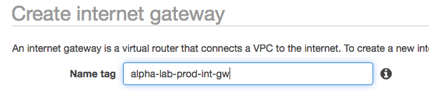

click  and then  . Attach your newly created Internet Gateway to your VPC, ensure it is highlighted

1. Click on  and select ‘Attach to VPC’ , click VPC and select ‘alpa-lab-prod’ from the drop down menu

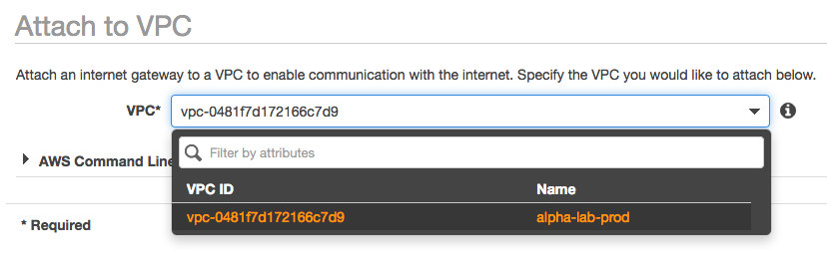

Hit the  button.

***2.5 – Create Sub or Custom Route Table***

1. **Create a** **Sub or Custom Route Table for your VPC** - within the ‘Virtual Private Cloud’ menu, click on ‘Route Tables’,

create a Route Table by clicking on  the upper left corner of the console, name it ‘alpha-lab-prod-sub-rt’, click VPC and select ‘alpha-lab-prod’ from the drop-down menu to associate it with your VPC

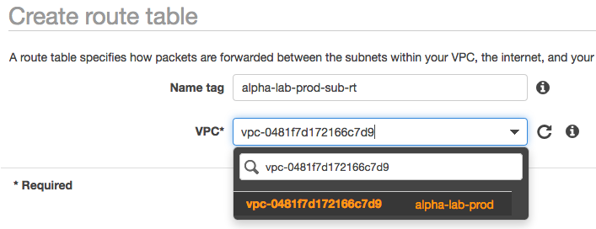.

Click  and then the button.

1. Highlight your newly created sub Route Table by clicking anywhere on its row in the Route Table table.

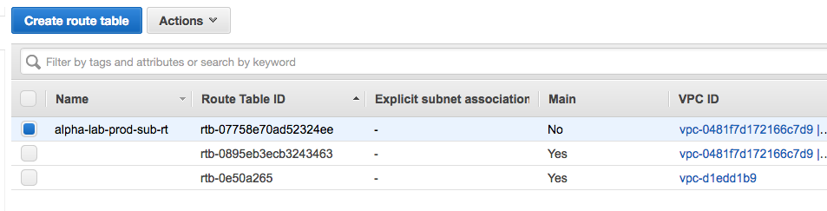

1. Click on the ‘Routes’ tab - second tab (lower left corner of your console),

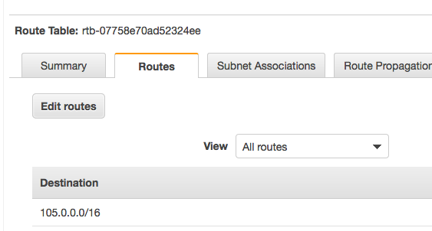

click on , then on . Beneath the field ’Targets, click and select ‘Internet Gateway’ and select the Internet Gateway ‘alpha-lab-prod-int-gw’ from the drop-down menu, Destination - key in ‘0.0.0.0/0’.

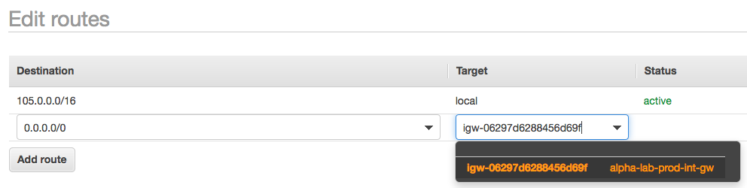

Hit the  button and then the  button.

1. Explicitly assign your public subnet ‘alpha-lab-prod-pub’ to your sub Route Table ‘alpha-lab-prod-sub-rt’. Ensure your sub Route Table is highlighted by clicking anywhere on its row in the Route Table table,



then click on the third tab - ‘Subnet Associations’ (lower left corner of the console)

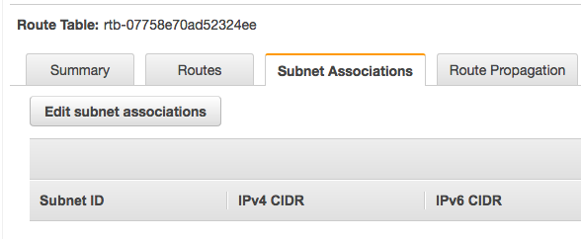

and click the ‘Edit subnet Associations’ button, highlight your public subnet ‘alpha-lab-prod-pub’

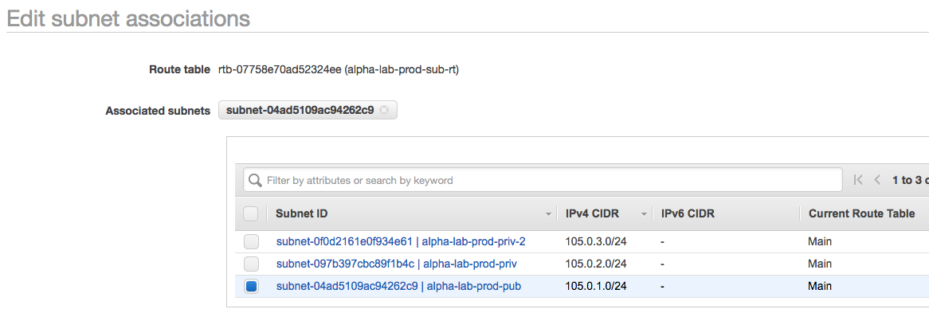

and hit the  button and then the  button.

***2.6 – Create NAT Gateway***

1. **Create a** **NAT Gateway** and route internet traffic from the Main Route Table to it. Within the ‘Virtual Private Cloud’ menu, click on ‘NAT Gateways,



create a NAT Gateway by clicking  on the upper left corner of the console. Next to the field subnets - click and select your public subnet ‘alpha-lab-prod-pub’, next to the ‘Elastic IP Allocation ID – click .

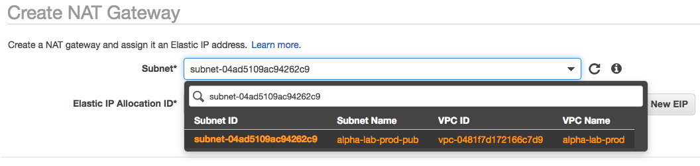

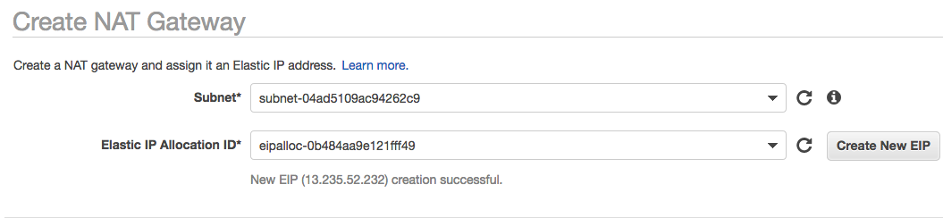

Click the button.

1. Beneath the green success prompt, click , highlight your Main Route Table by clicking on the row and checking the ‘Summary’ tab for ‘alpha-lab-prod and ‘Main’ field - Yes.

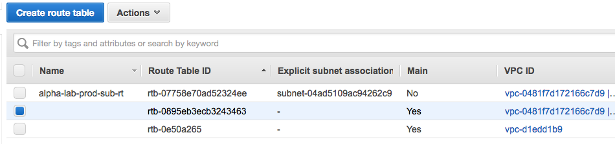

Click the ‘Route’ tab,

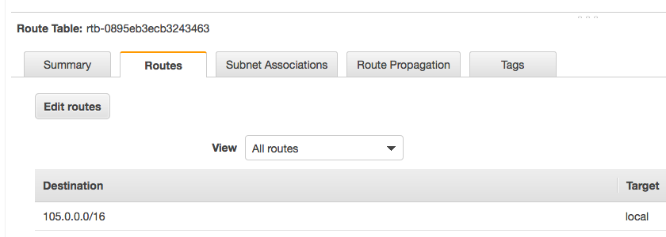

followed by the  button, then click the  button, Beneath the field ’Targets, click and select ‘NAT Gateway’ and select the populated NAT Gateway from the drop-down menu, Destination - key in ‘0.0.0.0/0’.

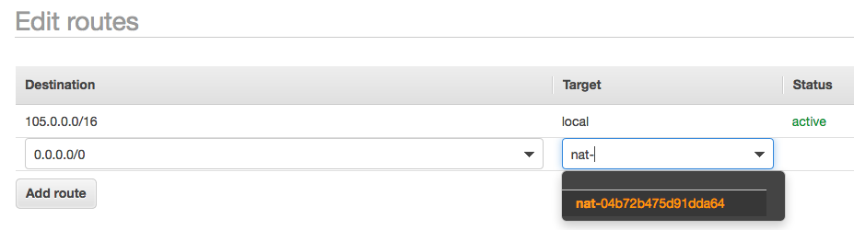

Hit the  button and then the  button.

***2.7 – Provision a Linux EC2 Instance***

1. Provision a Linux EC2 instance in the public subnet which shall serve as our Web Server. Click on  (upper left corner of the console) that is on the AWS menu bar, click on ‘EC2’ found within the sub-menu ‘Compute’



or Key in ‘EC2’ in the search bar and select it from the drop-down menu.



1. Click  (midway left side of the console), in the tab ‘Quick Start’ choose ‘Amazon Linux AMI



select a ‘t2.micro’ Instance Type, by clicking anywhere on its row.



1. Click the button (bottom right corner of the console). Click the drop-down menu next to the Network field and select your VPC ‘alpha-lab-prod’, Subnet - select ‘alpha-lab-prod-pub’, Auto-Assign Public IP - select ‘Enabled’, Leave the remaining configurations in their default state.

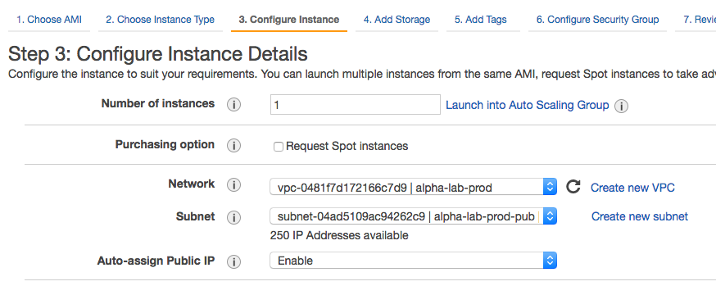

1. Now click on the 6th tab -  (upper section of the console, below the AWS menu bar), click the ‘Select an existing Security Group’ radio button, highlight ‘alpha-lab-prod-sg-pub’.

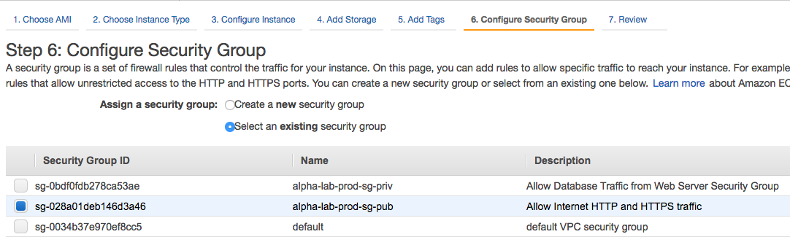

Click the  button ( bottom right corner of the console), after that click the  button, then in the Key Pair dialogue box, click the drop down and select ‘Create new Key Pair, name your Kay Pair ‘alpha-lab-prod-pub-kp’

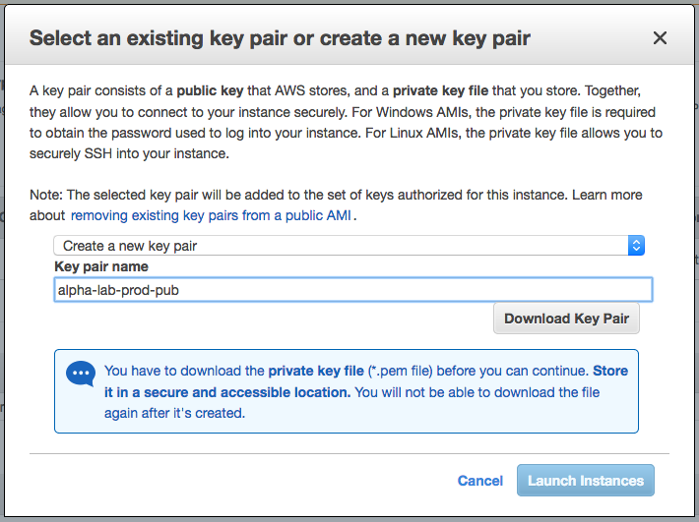

download your Key Pair by clicking the  button.

Finally click  to launch your EC2 instance.

1. Login to your newly created EC2 Instance via SSH. After launching your Instance, click on the  button (lower right corner of the console). Next to the ‘Launch Instance’ button click the  button, Leave the default radio button selection ‘I would like to connect with - A standalone SSH Client’

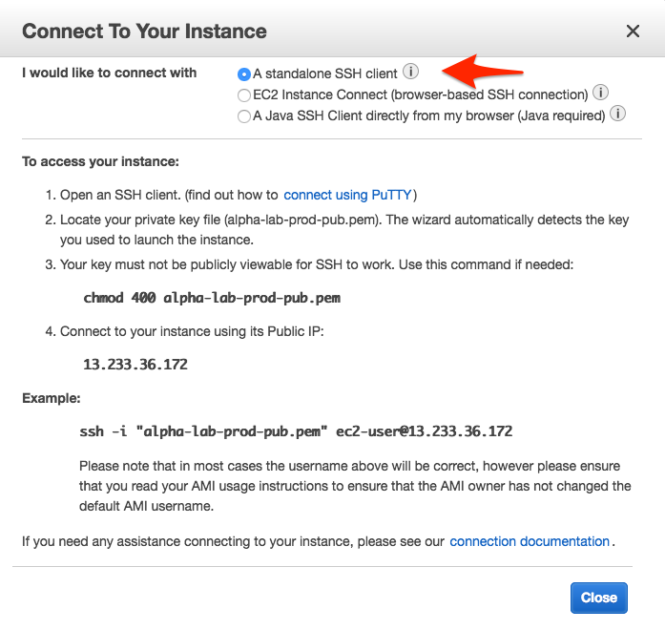

If you working on a Mac or Linux computer, launch your terminal, if you are on a Windows computer install and use a Putty ssh client. After launching your terminal, cd or change directory to the location where you saved your Key Pair (in the terminal, type in ‘cd Downloads’ and hit Enter.

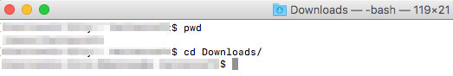

1. Copy the command ‘chmod 400 alpha-lab-prod-pub.pem’ from the dialogue box in the console, paste it in your terminal and hit Enter (this will change the permission of your key pair making it viewable by ssh.

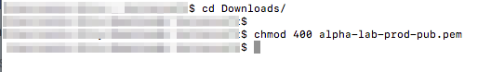

1. Copy the command ‘ssh -i "alpha-lab-prod-pub.pem" ec2-user@13.233.36.172’

(your instance public key and name) from the dialogue box in the console, paste in your terminal and hit enter to log into your EC2 instance via ssh,

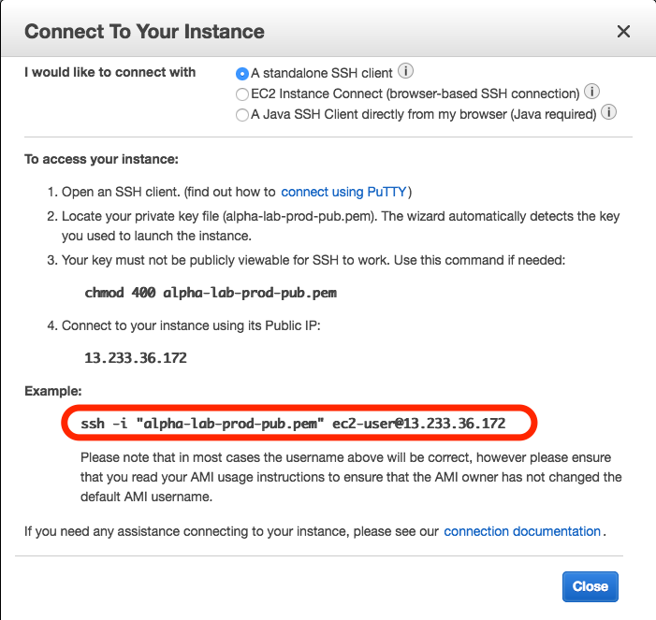

you will receive a warning about the hosts authenticity and wether you are sure you want to login, type in ‘yes’ and hit Enter.

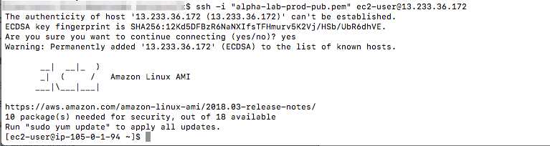

1. Once you have logged in, key in ‘sudo su - ‘ and hit Enter to upgrade your privileges on the systems and ‘yum -y update’ to update your EC2 instance.

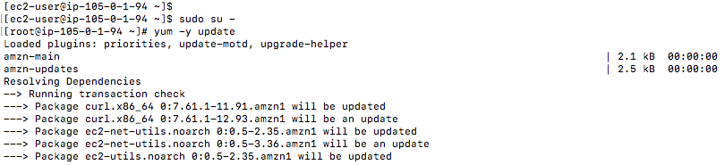

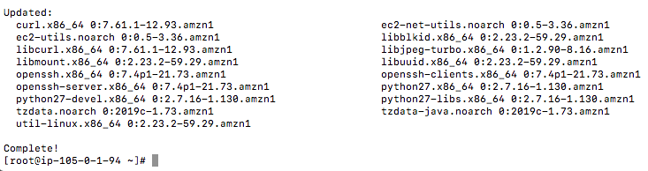

1. Next install the Apache Web Server by keying in ‘yum install -y httpd24 httpd24-tools mod24_ssl’ and hitting Enter.

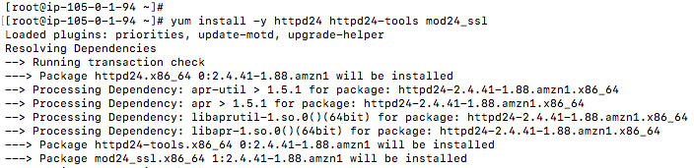

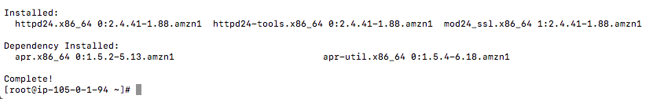

1. After installation set Apache Server to start automatically upon system start up key in ‘chkconfig httpd on’ and hit enter, then key again ‘service httpd start’ and hit Enter.

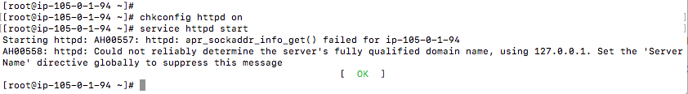

1. Name your Web Server and Test to confirm that it is up and running.

Highlight your instance and click the icon below the name field and name your instance ‘alpha-lab-dev-web’

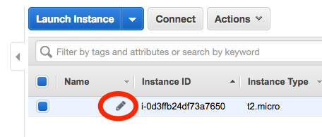 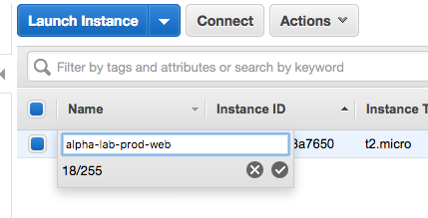

1. In the ‘Descriptions’ tab, hover your curser next to the ‘IPv4 Public IP (lower right corner of the console) and click on the copy icon to copy the public IP address of your EC2 instance.

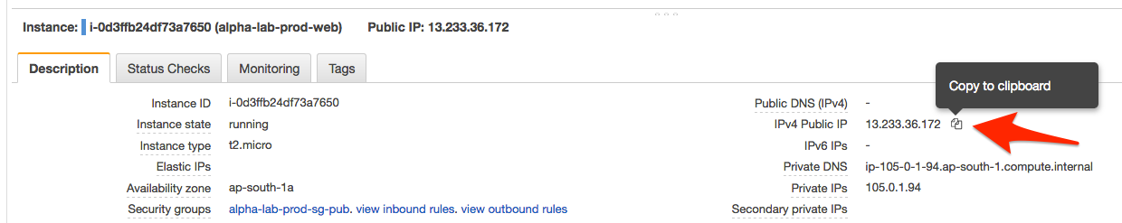

1. Paste the copied IP address in a new tab in your web browser and hit Enter.

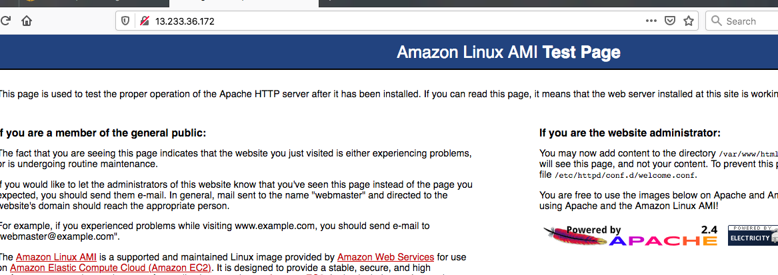

If you see the page above: ‘Amazon Linux Ami Test Page… this page is use to test the proper operation if the Apache HTTP server after it has been installed…’ Then your congratulations your configurations are CORRECT and your Web Server in the public subnet is accessible to every user on the internet.

***2.8 – Provision an RDS – MySQL Database***

1. **Provision an RDS database** and place it in the private subnet where it only receives ingress database traffic from your public / Web Servers Security Group. Click on  (upper left corner of the console that is on the AWS menu bar, click on ‘RDS’ found within the sub-menu ‘Database’ or Key in ‘RDS’ in the search bar and select it from the drop-down menu.

 OR 

1. Click the  button on the lower left section of the console, Leave the default ‘Standard Create’ Database Creation Method, Engine Options - click MySQL, Edition - leave the default selection, templates - select / click on ‘Free Tier,



1. Within Settings, DB Instance Identifier - ‘alpha-lab-prod-db’, Master Username - ‘alpha_prod_root’, Master password ‘manager101’, Confirm password ‘manager101’.

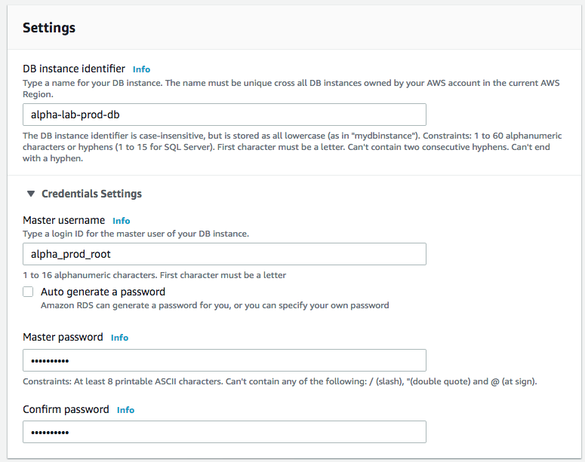

1. For DB Instance Size, Storage: Uncheck ‘Storage autoscaling’, Availability & Durability - leave the default values for the remaining configurations.



1. Within Connectivity, click VPC and select ‘alpha-lab-prod’, Within ‘Additional Connectivity Configurations’ Subnet Group - leave default (Create New DB Subnet Group), Public Accessibility - select ‘No’, VPC Security Group - select ‘Choose Existing and select ‘alpha-lab-prod-sg-priv’ from the drop-down menu.

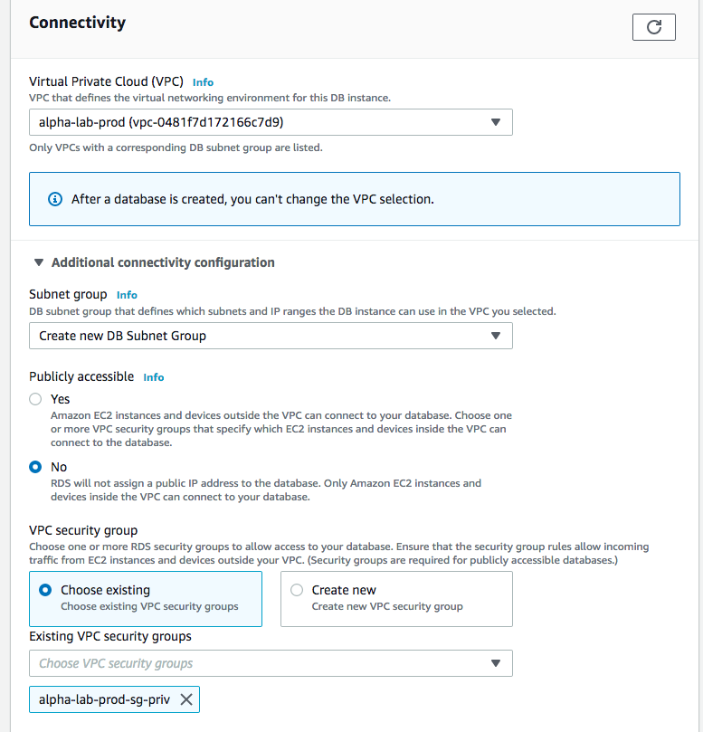

1. Database Port - leave default (3306), Database Authentication - leave default (Password Authentication), Within Additional Configurations, Initial Database Name - ‘alpha_lab_prod_db001’. Under ‘Backup – Uncheck ‘Enable automatic backups and Leave all other configurations with default values.

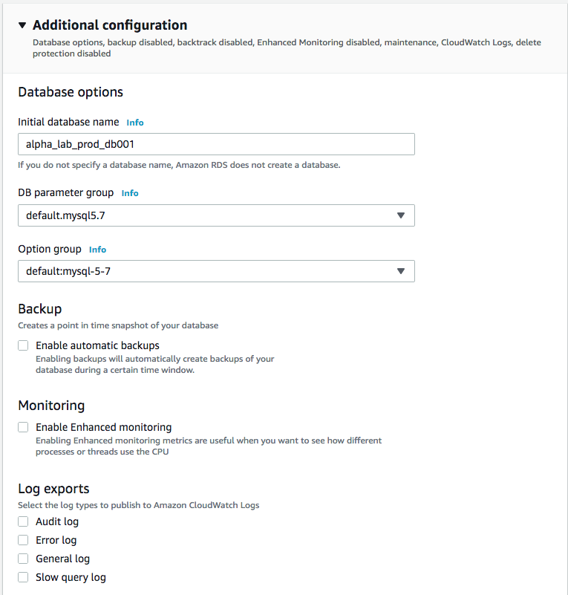

scroll to the end, click the  button.

1. Test your RDS database connectivity using MySQL Workbench - an SQL Client Tool, which performs an SSH login into your Web Server in the public subnet and from your web server, it established a connection to your RDS database on port 3306. In your MySQL Connection / login window, you will key in the following credentials. Connection Method - select Standard TCP/IP over SSH, SSH Hostname - ‘Your Web Servers public DNS or public IP address’, SSH Username - ‘ec2-user’, SSH Key File - ‘/path/alpha-lab-prod-pub.pem’, MySQL Hostname - ‘copy and paste in your RDS-endpoint’ ( RDS > Databases > alpha-lab-prod-db > connectivity & security > endpoint ), MySQL Port - ‘3306’, Username - ‘alpha_prod_root’, Password - ‘manager101’. Finally click the Test Connection or Connect button.

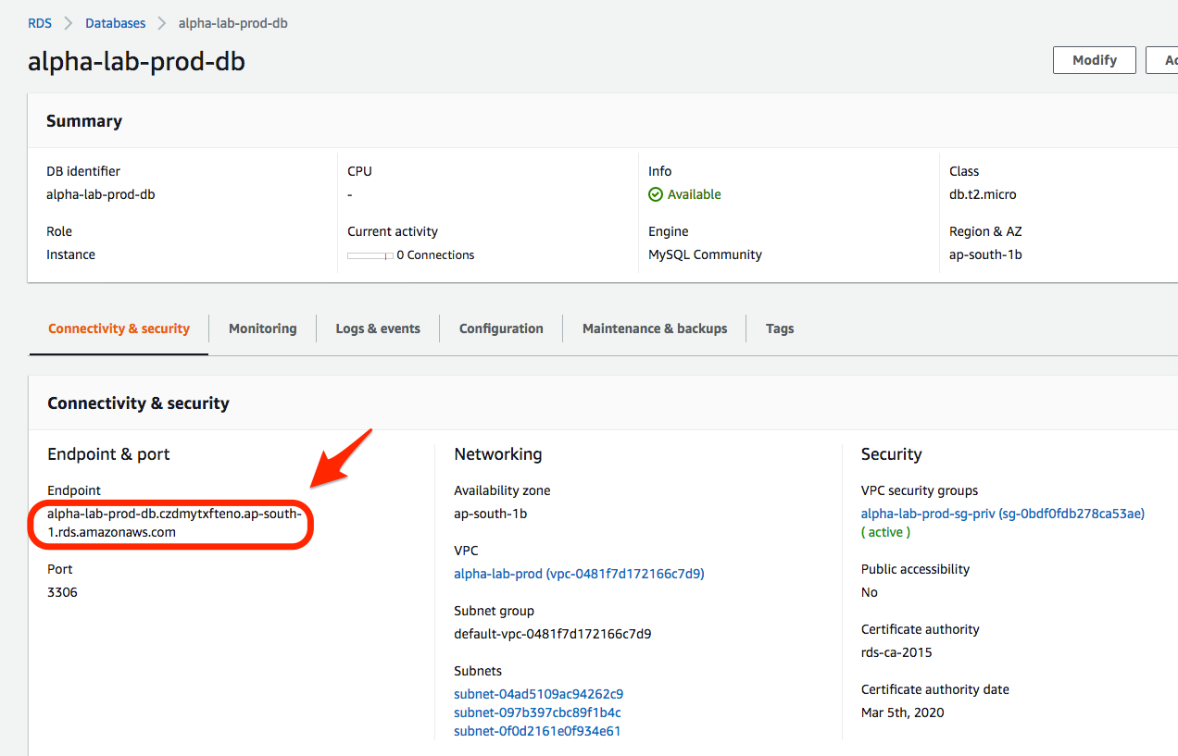

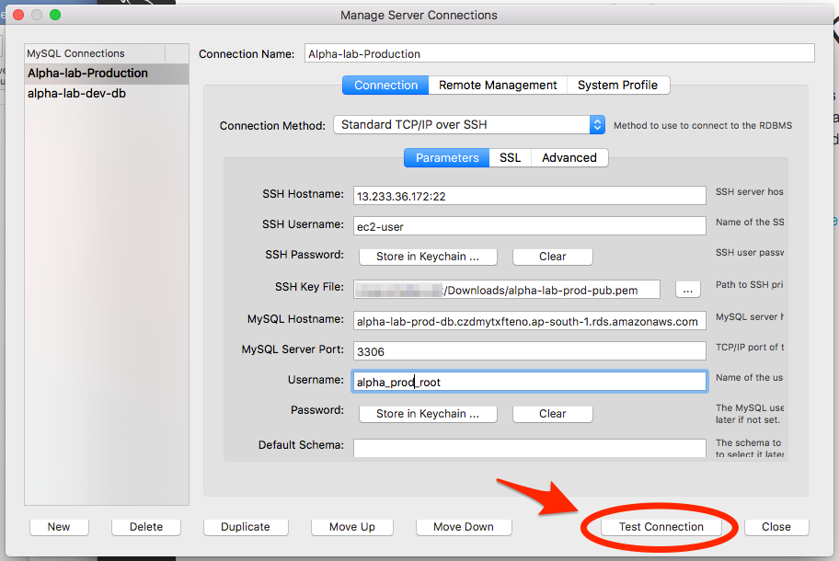

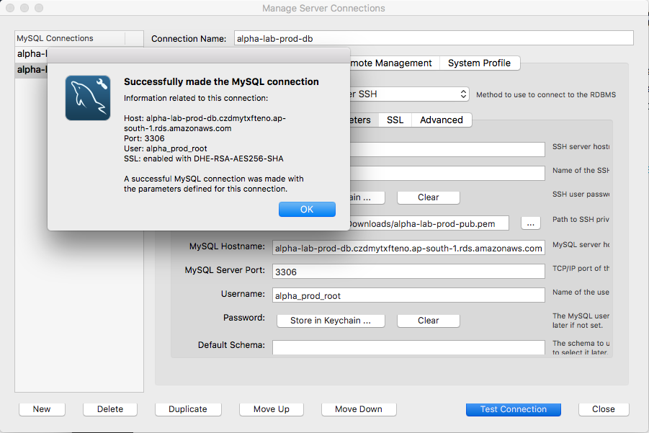

1. **Carry out Inter-Region VPC Peering (Connecting both VPCs)**

***3.1 – Create a Peering Connection***

1. **Inter-region VPC Peering** – Ensure you are in the Asia Pacific (Mumbai) AWS region or at the top right corner of the console, select your AWS region - Asia Pacific (Mumbai).



Click on  - found on the menu bar, at the top left corner of the console and select VPC found under Networking & Content Delivery, or type in ‘VPC’ and select it beneath the search bar.

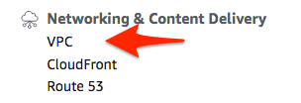 or 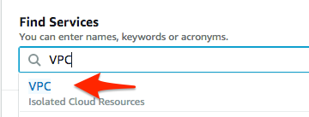

1. At the top left corner, Within the sub-menu ‘Virtual Private Cloud’, click on ‘Your VPC’,

highlight ‘alpha-lab-prod’

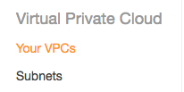 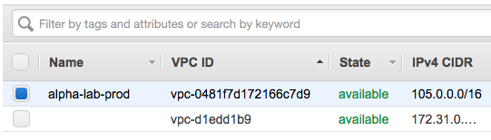

1. hover your curser next to VPC ID (found in the ‘Description tab - lower left corner of the console) until the copy icon appears and copy the VPC ID of ‘alpha-lab-prod’.

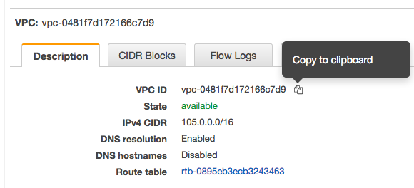

Now change your AWS region (upper corner of the console) to EU (London)

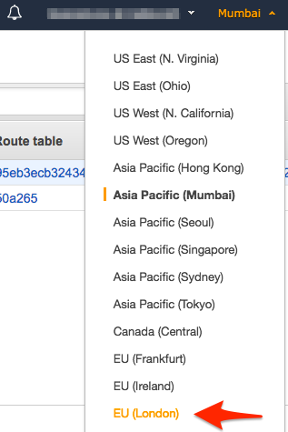

1. Click on ‘Peering Connections’ within the ‘Virtual Private Cloud’ sub menu.

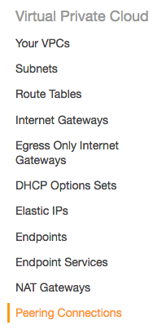

1. Click on the  button (upper left corner of the console), name your Peering Connection ‘alpha-lab-dev-to-prod’, VPC Requester - select ‘alpha-lab-dev’ from the drop-down menu, Account - leave the default (my account, Region - click the region button to select ‘Another region’, also select Asia Pacific (Mumbai from the drop-down menu. VPC Accepter - paste in the VPC ID of ‘alpha-lab-prod’ which you copied above. Hit the  button (lower right corner of the console).

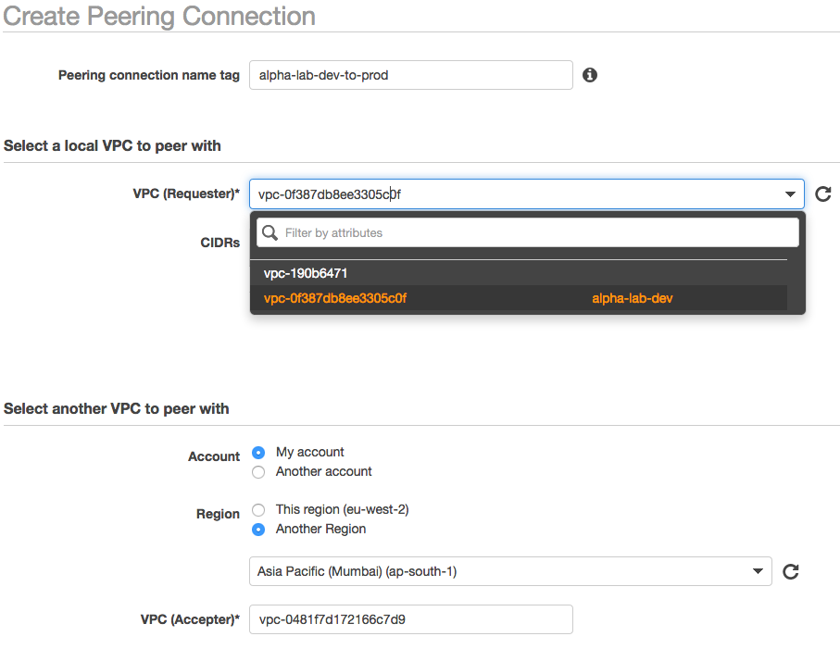

1. Change your AWS region again to Asia Pacific (Mumbai)

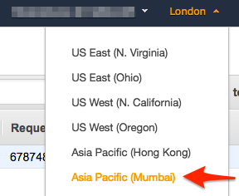

and click the  button on the upper left corner of the console - next to ‘Create Peering Connection’, select ‘Accept request from the drop-down menu and click the blue ‘Yes Accept’ button.

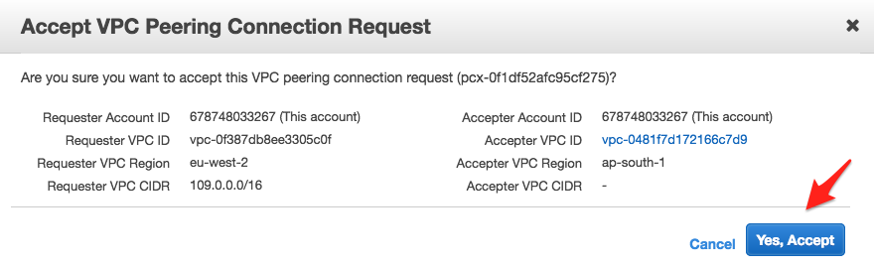

1. In the table the status of your highlighted ‘Peering Connection’ should change from a yellow knob (Pending Acceptance) to a green knob (Active).

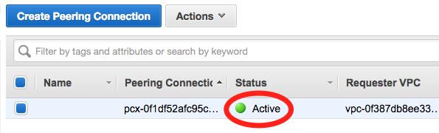

***3.2 – Add VPC Peering Route Entries***

1. **Add your Peering VPCs (both Accepter and Requester) IP range as Route entries into the Sub Routing Table of each VPC**.

While in AWS region Asia Pacific (Mumbai), within the sub menu ‘Virtual Private Cloud’ click on ‘Routing Tables’

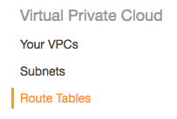

and highlight ‘alpha-lab-prod-sub-rt’, click on the second tab (lower left corner of the console) ‘Routes’,

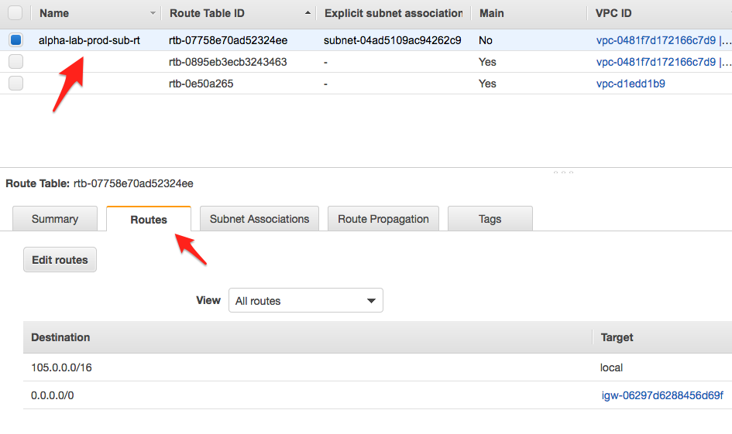

1. Now click  and then click , beneath the field ’Target - select ‘Peering Connection’ from the drop-down menu, beneath Destination - key in ’109.0.0.0/16’ (the ip range of your test environment - alpha-lab-dev),

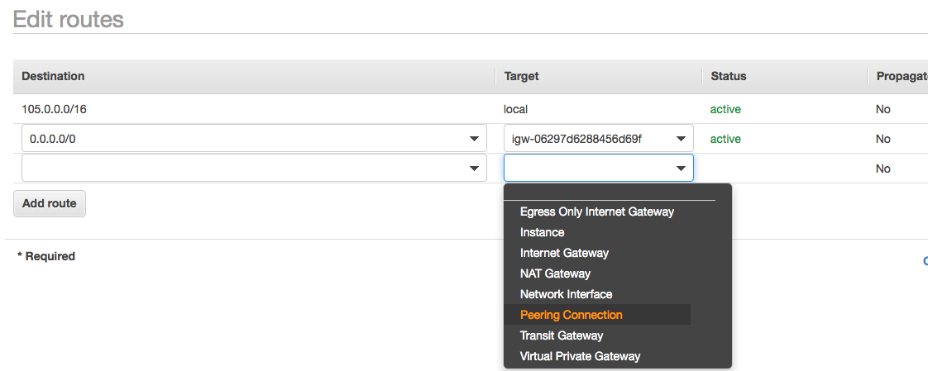

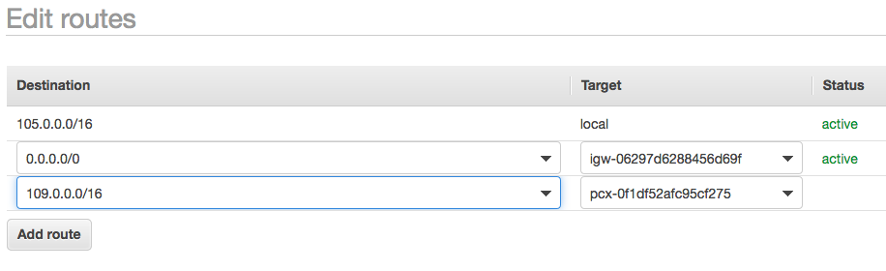

click the  button and then the  button.

1. Change your AWS region to EU (London),



within the sub menu ‘Virtual Private Cloud’ click on ‘Routing Tables’ and



1. Highlight ‘alpha-lab-dev-sub-rt’, click on the second tab (lower left corner of the console) ‘Routes’,

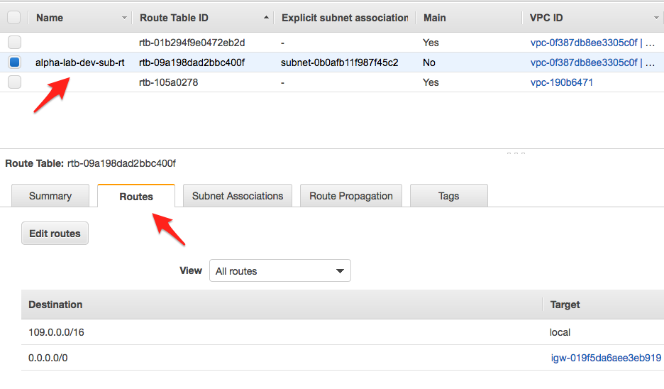

1. Now click  and then click  , beneath the field ’Target - select ‘Peering Connection’ from the drop-down menu, beneath Destination - key in ’105.0.0.0/16’ (the ip range of your production environment - alpha-lab-prod),

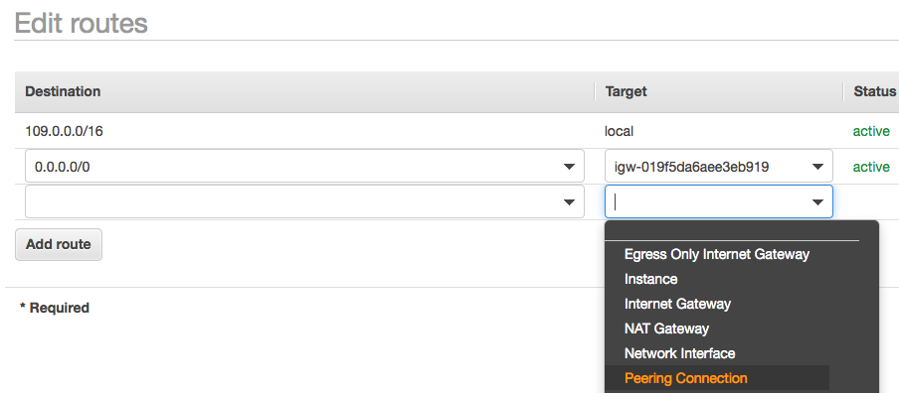

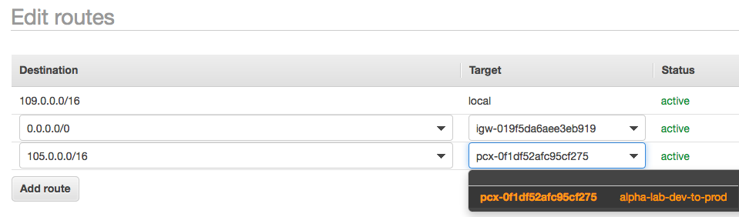

click the  button and then the  button.

1. **Perform connectivity tests to ensure resources (EC2 Instances) in the two VPCs can communicate with each other.**

***4.1 – Log into both your Test and Production Web Server via SSH***

1. Test your Inter-Region Peering Connection - Log into your Test Web Server and perform a connectivity test, ‘ping’ your Production Web Server, using its private ip address. After that log into your Production Web Server and perform a connectivity test (ping) your Test Web Server, using its private IP address. This should serve as proof that both VPC though in different regions are peered and resources in each VPC are communicating with resources in the other.

While your are in the AWS region EU (London), Click on  , then on EC2,

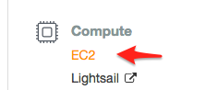

1. Now click on ‘Running Instances’

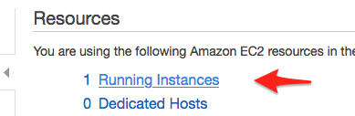

1. Highlight your Test web server ‘alpha-lab-dev-web’, Next to the ‘Launch Instance’ button click the  button, Leave the default radio button selection ‘I would like to connect with - A standalone SSH Client’

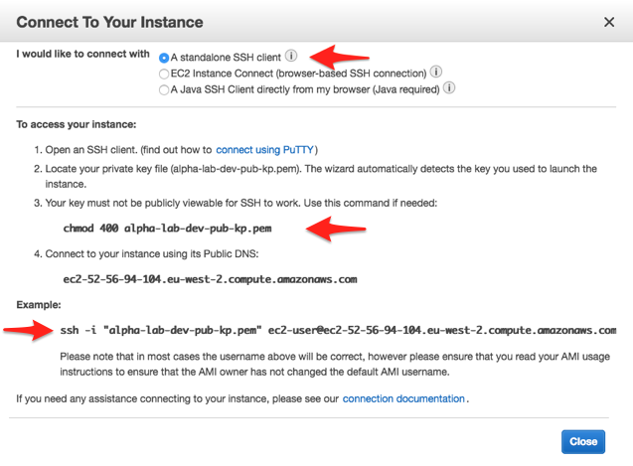

If you working on a Mac or Linux computer, launch your terminal, if you are on a Windows computer install and use a Putty ssh client. After launching your terminal, cd or change directory to the location where you saved your Key Pair (in the terminal, type in ‘cd Downloads’ and hit Enter.



1. Copy the command ‘chmod 400 alpha-lab-dev-pub-kp.pem’ from the dialogue box in the console, paste it in your terminal and hit Enter (this will change the permission of your key pair making it viewable by ssh.



1. Copy the command ‘ssh -i "alpha-lab-dev-pub-kp.pem" ec2-user@ec2-3-8-102-102.eu-west-2.compute.amazonaws.com’ (your instance name) from the dialogue box In the console, paste in your terminal and hit enter to log into your EC2 instance via ssh,



you will receive a warning about the hosts authenticity and wether you are sure you want to login, type in ‘yes’ and hit Enter.



1. Log into your production Web Server ‘alpha-lab-prod-web’

Switch your AWS region to Asia Pacific (Mumbai)

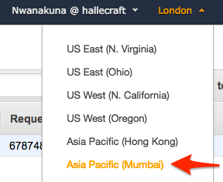

1. Highlight your production Web Server ‘alpha-lab-prod-web’.

Next to the ‘Launch Instance’ button click the  button, Leave the default radio button selection ‘I would like to connect with - A standalone SSH Client’

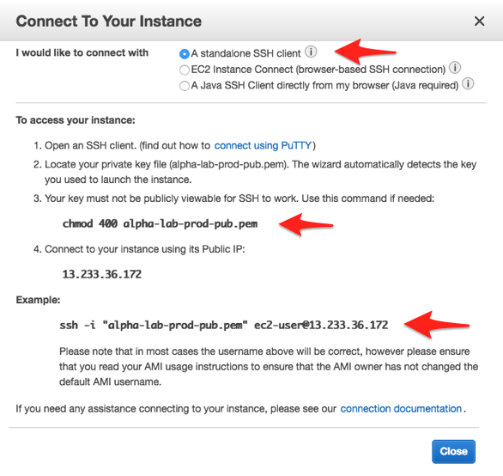

If you working on a Mac or Linux computer, launch your terminal, if you are on a Windows computer install and use a Putty ssh client. After launching your terminal, cd or change directory to the location where you saved your Key Pair (in the terminal, type in ‘cd Downloads’ and hit Enter.



1. Copy the command ‘chmod 400 alpha-lab-prod-pub.pem’ from the dialogue box in the console, paste it in your terminal and hit Enter (this will change the permission of your key pair making it viewable by ssh.



1. Copy the command ‘ssh -i "alpha-lab-prod-pub.pem" ec2-user@13.233.36.172’

(your instance public key and name) from the dialogue box in the console, paste in your terminal and hit enter to log into your EC2 instance via ssh,



You will receive a warning about the hosts authenticity and wether you are sure you want to login, type in ‘yes’ and hit Enter.



***4.2 – Perform Two-way Connectivity Tests – against Test Web Server and Web Production Server***

1. Once you have logged into your test web server and also your production web server, key in

‘sudo su - ‘ in each terminal and hit Enter ( this will upgrade your privileges),

test web server – ‘alpha-lab-dev-web’

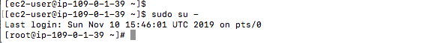

production web server ‘alpha-lab-prod-web’

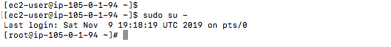

1. While in the AWS region Asia Pacific (Mumbai), Highlight your production web server ‘alpha-lab-prod-web’, hover next to the private address on the Description tab and click to copy as soon as the copy icon appears

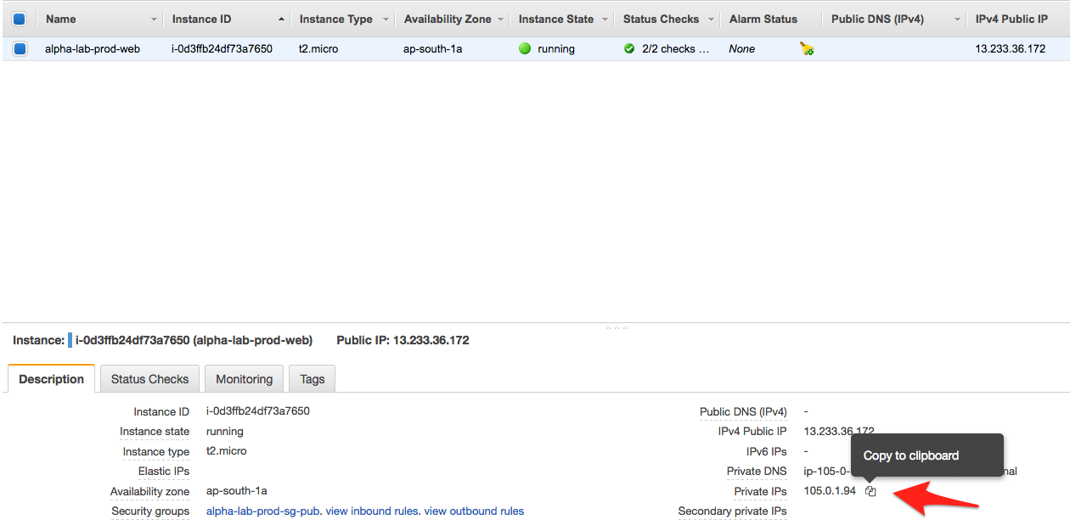

1. On the Test Web Servers terminal ‘alpha-lab-dev-web’ ping your production web servers private IP address by keying in ‘ping ‘ and pasting in the copied IP address.

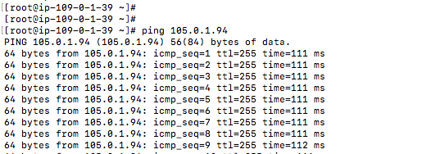

1. Change your AWS region to EU (London)

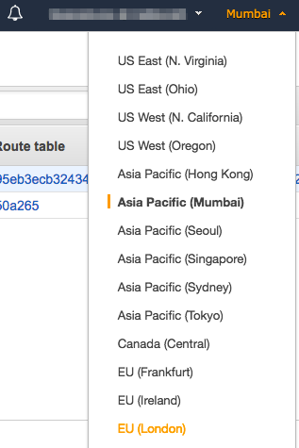

1. Highlight your Test Web Server ‘alpha-lab-dev-web’, hover next to the private address on the Description tab and click to copy as soon as the copy icon appears

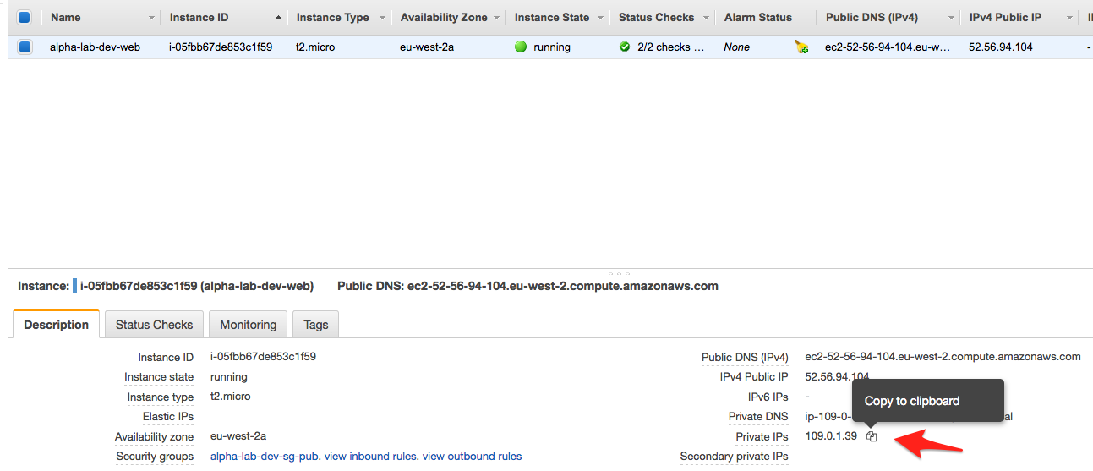

1. On the Production Web Servers terminal ‘alpha-lab-prod-web’ ping your test web servers’ private IP address by keying in ‘ping ‘ and pasting in the copied IP address.

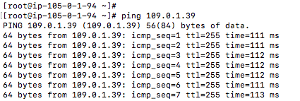

Congratulations upon your successful completion of this lab. Echo Replies on both Test and Production Web Servers using their Private IP addresses is evidence that the instances can communicate with each other and proof that Inter-region VPC peering is configured and functioning properly.